



Project Report On

#### Online Cafe and Restaurant Management System

**Submitted**

by

#### Roshni Shaileshbhai Gamit

**Enrollment No.: 3060820006**

in partial fulfillment for the award of the degree of

#### Bachelor of Technology in

**Agricultural Information Technology**

###### College of Agricultural Information Technology Anand Agricultural University

**Anand – 388 110 GUJARAT (INDIA) 2025**

Internship Project (**PRJT – 421**)

## CANDIDATE’S DECLARATION

I declare that final semester report entitled **“Online Cafe and Restaurant Management System”** is my own work conducted under the supervision of the guide **Mr.Jaydeep Rakholiya** and **Mr. D.K.Parmar** I further declare that to the best of my knowledge, the report for B. Tech final semester does not contain part of the work which has been submitted for the award of B. Tech Degree eitherin this university or any other university without proper citation.

Gamit Roshni S. (3060820006)

**College of Agricultural Information Technology Anand Agricultural University, Anand – 388 110**

# CERTIFICATE

This is to certify that the project entitled **“Online Cafe and Restaurant Management System”** has been carried out by **Gamit Roshni Shailesbhai** – **3060820006** under my guidancein partial fulfillment of the degree of Bachelor of Technology in **Agricultural Information Technology** of Anand Agricultural University, Anand during the academic year **2025**.

**Date:**

**Internal guide**

Mr. D.K Parmar

**(Assit.prof of AIT)**

# Acknowledgement

Towards the successful completion of my B. Tech in Agricultural Information Technology, Anand Agricultural University, Anand . final year project training in Excelsior Technologies, I feel greatly obliged to certain specials. I am sincerely gratitude to Mr. Jaydeep Rakholiya of Excelsior Technologies, Ahmadabad, who is providing me this opportunity and necessary support during the development of the project. I am also grateful to all staff members of this company for providing all the technical assistance and helping in solving problems arising during developments.

I heartily thankful to Mr. D.K. Parmar for his time, suggestions, support and guidance without whom this project would have been a tough task.

I have no other words to express my sincere thanks to all faculties of

B. Tech in College of Agricultural Information Technology, AAU, Anand for their kind co-operation and able guidance.

- Roshni Shaileshbhai Gamit

# Abstract

"Online Cafe and Restaurant Management System" is a state-of-the-art web application thoughtfully developed to transform the way cafes and restaurants operate in the digital age. Designed by aspiring developers with a vision for innovation, this platform reimagines traditional dining management by offering a comprehensive and user-centric experience.With an elegant and intuitive interface, the system empowers customers to explore menus, place orders, and interact with administrators effortlessly. On the backend, administrators can efficiently manage users, menus, orders, inventory, and real-time communication through a feature-rich dashboard. The platform is built using modern web technologies like ASP.NET Core MVC and SQL Server, ensuring robust performance, security, and scalability.Key highlights include dynamic location-based dropdowns (Country-State-City), secure image handling, captcha-based validations, and asynchronous operations for smooth navigation. Additionally, the integration of SignalR-based live chat facilitates seamless interaction between users and administrators, enhancing customer engagement and satisfaction.By digitizing and optimizing core restaurant processes, the Online Cafe and Restaurant Management System delivers a smart, secure, and efficient environment—perfectly suited to meet the demands of today’s fast-paced food service industry. It’s more than just software—it’s a leap toward the future of digital hospitality.

# Company Profile

#### Company Overview

Excelsior Technologies is a forward-thinking software development and IT solutions provider committed to delivering innovation-driven services tailored to meet the unique needs of modern businesses. With a passion for excellence and a team of experienced developers, designers, project managers, and QA professionals, we help startups, SMEs, and enterprises accelerate their digital transformation journey. From conceptualization to deployment, we ensure high-quality and scalable digital solutions that drive measurable results.  
With a legacy of successfully delivering numerous domestic and international projects, Excelsior Technologies has positioned itself as a reliable partner for clients seeking robust, secure, and user-friendly applications across platforms.

#### Why Choose Excelsior Technologies?

For over a decade, Excelsior Technologies has consistently delivered cutting-edge digital products that exceed client expectations. Our team brings 3 to 8 years of domain experience across industries, ensuring we can manage projects of any scale or complexity. We focus on creating value by building secure, maintainable, and performance-optimized systems. Whether you're launching a new idea or upgrading legacy systems, our team brings the strategic insight and technical prowess to make it happen—on time and within budget.

### Services:

1. Custom Web Development
2. Mobile Application Development
3. E-commerce and CMS Solutions
4. UI/UX Design and Prototyping
5. IT Consulting Services

## Technologies:

##### Microsoft Practices:

1. .NET, .NET CORE
2. MS Team Development
3. Angular/Node
4. React/Node
5. MongoDB
6. PHP-MySQL

##### Mobile:

1. iOS Development
2. Android Development
3. Flutter Development
4. Cross Platform Responsive Design

##### Web:

1. HTML and CSS
2. Bootstrap
3. JQuery
4. Json
5. Angular JS
6. React Native
7. Node.js
8. Drupal
9. WordPress
10. Magento
11. UI/UX Design

# Index

1. Introduction to Project
   1. Problem Summary. 01
   2. Project Purpose 01
   3. Project Scope or Outcome. 01
   4. Goals & Objectives. 02
   5. Key Features. 02
   6. Technology and Literature Overview. 06
2. Project Management
   1. Project Planning and Scheduling. 09
   2. Estimation. 13
   3. Risk Identification, Analysis, and Management 15
3. System Requirement Study
   1. User Characteristics. 19
   2. Functional/Non-Functional Requirements. 20
   3. Software and Hardware Requirements. 22
4. System Analysis
   1. Study of Current System. 23
   2. Problems in Current System. 23
   3. Requirement of New System. 23
   4. Feasibility Study. 24
   5. Functions of System – Use Case Diagram. 24
   6. Features of New System. 24
5. System Design
   1. Functional and Behavioural Modeling – DFD. 26
   2. UML Diagrams. 30
   3. E R Diagram. 33
   4. Data Dictionary. 34
6. Implementation Environment
   1. Implementation Environment. 40
   2. Program / Modules Specification with Screenshots 43
   3. Security Features. 58
7. Testing
   1. Testing Plan. 60
   2. Testing Methods 60
   3. Test Cases… 62
8. Limitations 64
9. Conclusion. 65

## Introduction:

#### Problem Summary:

In today’s fast-paced digital era, the food and hospitality industry is undergoing a significant transformation. However, many cafes and restaurants still rely on outdated, manual systems for managing their operations, resulting in inefficiencies, poor customer service, and loss of business opportunities. The lack of an integrated and user-friendly online platform prevents cafes and restaurants from fully digitizing their processes such as order management, table reservations, menu updates, customer feedback, and payment processing leading to fragmented service experiences.

From the customer's perspective, common challenges include long wait times, difficulty placing online orders, lack of real-time menu visibility, and limited engagement or feedback options. For restaurant owners and staff, issues like inefficient kitchen coordination, poor inventory tracking, billing inaccuracies, and difficulty analyzing performance data add to operational stress and hinder growth.

Moreover, the absence of real-time data access, secured digital payments, and automated communication systems affects business reliability and scalability. These gaps highlight the urgent need for a centralized Online Cafe and Restaurant Management System that seamlessly integrates frontend ordering with backend operations—enhancing user satisfaction, optimizing workflow, and ensuring sustainable business development in a competitive marketplace.

#### Project Purpose:

The primary objective of this project is to design and develop a comprehensive Online Cafe and Restaurant Management System that streamlines operations and enhances the overall customer experience. By integrating modern web technologies with intuitive design, the system aims to simplify restaurant processes such as online ordering, table reservations, menu management, staff coordination, billing, and customer feedback collection.

#### Project Scope:

The scope of this project encompasses the development of a robust and feature-rich Online Cafe and Restaurant Management System, designed to streamline operations, enhance customer engagement, and enable seamless online ordering and management functionalities.

These include but are not limited to:

* + - User-friendly and visually appealing menu interfaces
    - Enable customers to effortlessly browse food categories, view dish details, and filter items by popularity, availability, or dietary preferences.
    - Secure and seamless order placement and payment processing
    - Ensure customer trust through encrypted transactions, multiple payment gateway support (UPI, cards, wallets), and smooth checkout experiences.
    - Comprehensive order and table management system
    - Facilitate real-time order tracking, table reservation, kitchen order tickets (KOT), and delivery updates to streamline service and minimize delays.
    - Dynamic and customizable admin dashboard
    - Allow restaurant administrators to manage users, menu items, pricing, offers, and promotions with ease from a centralized interface.
    - Inventory and stock monitoring tools
    - Help maintain ingredient availability, reduce waste, and send automated low-stock alerts to streamline kitchen operations.
    - Role-based access and staff management
    - Assign permissions for admins, chefs, delivery personnel, and waiters to ensure secure and efficient task delegation.

#### Project Objectives:

* To develop an innovative and user-focused Online Cafe and Restaurant Management System that delivers a seamless food ordering and dining experience, empowers restaurant owners to efficiently manage operations, and enhances customer satisfaction and engagement ultimately driving service quality, operational efficiency and brand loyalty.

#### Technologies Used:

* **HTML (Hyper Text Markup Language):**

**Purpose:** Provides the basic structure and layout for web pages.

###### Key Features:

* + Defines elements such as headings, paragraphs, images, links, forms, etc.
  + Organizes content hierarchically using tags like <div>, <span>, <p>, <h1> to <h6>, etc.
  + Supports the inclusion of multimedia elements like images, videos, and audio.

#### jQuery:

**Purpose:** A JavaScript library that simplifies DOM manipulation and event handling.

###### Key Features:

* + Offers a concise and efficient syntax for selecting and manipulating DOM elements.
  + Provides methods for handling events such as click, hover, submit, etc.
  + Simplifies AJAX requests for asynchronous data retrieval from the server.
  + Facilitates animation effects and DOM traversal operations.

#### JavaScript:

**Purpose:** Enables dynamic and interactive behavior on web pages.

###### Key Features:

* + Supports variables, data types, operators, control structures, functions, etc.
  + Enables DOM manipulation for updating content, styles, and attributes dynamically.
  + Facilitates event-driven programming for handling user interactions.
  + Integrates with APIs to fetch data from servers, validate user input, and perform calculations.

#### React.js:

**Purpose:** React.js is a JavaScript library for building user interfaces, developed by Facebook.

###### Key Features:

* + Component-Based Architecture: Enables the creation of reusable UI components, which encapsulate their own logic and state.
  + Virtual DOM: Improves performance by rendering changes to the virtual DOM first, then selectively updating the real DOM.
  + Declarative Syntax: Defines UI components using a declarative syntax, making the code more predictable and easier to understand.
  + Unidirectional Data Flow: Facilitates the management of application state and data flow, leading to more predictable behavior.
  + Support for Single-Page Applications (SPAs): Enables the development of SPAs with

seamless navigation and dynamic content loading.

* + Large Ecosystem: Offers a rich ecosystem of libraries, tools, and community support for efficient development.

#### Tailwind CSS:

**Purpose:** Tailwind CSS is a utility-first CSS framework for rapidly building custom user interfaces.

###### Key Features:

* + Utility-First Approach: Provides a set of pre-defined utility classes for styling elements, avoiding the need for writing custom CSS.
  + Customization: Allows for rapid prototyping and customization through the configuration of utility classes.
  + Responsive Design: Supports responsive design out of the box, making it easy to create layouts that adapt to different screen sizes.
  + Modular and Compostable: Encourages the composition of UI components using utility classes, promoting code reusability.
  + Developer Experience: Enhances developer productivity with a consistent and predictable styling approach.

#### Node.js with Express.js:

###### Node.js:

**Purpose:** Node.js is a JavaScript runtime environment that allows you to run JavaScript code on the server-side.

###### Key Features:

* + Non-blocking I/O: Utilizes an event-driven, non-blocking architecture, making it highly efficient for handling concurrent requests.
  + Scalability: Supports horizontal scaling by allowing the creation of multiple instances to handle incoming requests.
  + Rich Ecosystem: Offers a vast ecosystem of libraries and packages through npm (Node Package Manager), facilitating rapid development.
  + JavaScript Everywhere: Enables full-stack JavaScript development, as the same language can be used on both the client and server sides.

#### Express.js:

**Purpose:** Express.js is a minimalist web application framework for Node.js, designed to streamline the development of web applications and APIs.

###### Key Features:

* + Routing: Provides a simple and intuitive API for defining routes and handling HTTP requests (GET, POST, PUT, DELETE, etc.).
  + Middleware: Supports middleware functions for intercepting and processing incoming requests before they reach the route handler.
  + Templating: Offers support for template engines like EJS, Pug, and Handlebars for generating dynamic HTML content.
  + Extensibility: Allows for the integration of additional middleware and third-party libraries to extend functionality as needed.

#### MongoDB:

**Purpose:** MongoDB is a NoSQL database solution known for its flexibility, scalability, and performance.

###### Key Features:

* + Document-Oriented: Stores data in flexible, JSON-like documents, making it easy to represent complex hierarchical data structures.
  + Scalability: Supports horizontal scaling through sharding, allowing you to distribute data across multiple servers.
  + Schema-less: Does not require a predefined schema, allowing for dynamic and evolving data models.
  + Rich Query Language: Provides a powerful query language with support for various operations like CRUD (Create, Read, Update, Delete), aggregation, indexing, etc.
  + High Availability: Offers features like replica sets and automatic failover to ensure data availability and reliability.

#### Tools Used:

###### Visual Studio Code:

* + An integrated development environment (IDE) for writing, editing, and debugging code.
  + Offers features such as syntax highlighting, code completion, and version control integration for efficient development workflows.

###### Postman:

* + A popular API development tool for designing, testing, and debugging APIs.
  + Allows for the construction of HTTP requests and the testing of API endpoints.
  + Supports automated testing and monitoring of API performance.

#### Project Implementation Details:

###### Frontend Development:

* + Utilize HTML, jQuery, and JavaScript to create the structure, behavior, and interactivity of the user interface.
  + Implement React.js components for building reusable UI elements and managing application state.
  + Style the frontend using Tailwind CSS, leveraging its utility-first approach for rapid styling and customization.

###### Backend Development:

* + Develop robust server-side logic using ASP.NET Core MVC to manage user interactions, process orders, and handle administrative operations efficiently.
  + Integrate SQL Server as the backend relational database to securely store and manage structured data, including user profiles, menu items, orders, feedback, inventory, and payment records.
  + Ensure data validation, security, and error handling are in place to protect user input and maintain system stability. Leverage Entity Framework Core or ADO.NET for seamless data access and manipulation using stored procedures or LINQ queries as needed.
  + Support dynamic and asynchronous operations using jQuery and Ajax, minimizing page reloads and enhancing the responsiveness of the user experience throughout the platform.

###### Testing and Debugging:

* + Use Postman for testing and debugging APIs, ensuring the reliability and performance of backend functionalities.
  + Write automated tests to validate API responses, perform data-driven testing, and monito API performance

#### Literature Review:

**Research Question:** What are the benefits of implementing an Online Cafe and Restaurant Management System, particularly for small and medium-sized food service businesses?

###### Key Findings:

* Global Market Reach:
  + Through the integration of online ordering, digital menus, and home delivery options, cafes and restaurants can cater to a wider customer base within their city or region.
  + By leveraging the internet, even small and local eateries can establish a digital presence, making their services accessible to customers through mobile devices and computers.
* Convenience for Customers:
  + This flexibility eliminates the need for customers to physically visit the cafe or restaurant, saving them time and effort.
  + This level of accessibility enhances customer satisfaction and encourages repeat business.
* Reduced Operational Costs:
  + By digitizing order taking, billing, inventory tracking, and staff scheduling, the system minimizes the need for extensive paperwork and reduces dependency on additional staff.
  + efficient inventory management help prevent overstocking and food wastage, lowering procurement costs.
* Data-Driven Insights:
  + The platform generates valuable insights through reports and analytics on sales trends, customer preferences, and inventory movement. These data points allow restaurant owners to make informed decisions on menu updates, promotional strategies, staffing, and procurement. and purchasing patterns.
* Enhanced Visibility and Brand Recognition:
  + Implementing an Online Cafe and Restaurant Management System significantly improves a restaurant’s visibility in the increasingly digital food service market.
  + This digital presence not only strengthens the restaurant’s brand identity but also encourages repeat business and positive word-of-mouth recommendations in a competitive market.

###### Best Practices: Developing an E-commerce Platform:

* + User-Centric Design:
    - Prioritize a smooth and intuitive user experience by designing clear menu layouts, easy navigation between categories, and a simple, fast ordering process.
    - Ensure the interface is responsive and optimized for all devices desktop, tablet, and mobile to allow customers to place orders or make reservations anytime, anywhere.
  + Security and Trustworthiness:
    - Implement strong security protocols to protect customer information and transaction data. Use HTTPS with SSL certificates, encrypt sensitive data, and follow industry standards to secure payment processing and user authentication.
    - Maintain secure session management to prevent unauthorized access and ensure customer trust.
  + Efficient Order Management and Fulfillment:
    - Develop a reliable backend system to handle order placement, real-time status updates, and inventory tracking. Integrate automated stock level monitoring and alert systems to prevent shortages and overstocking.
    - Facilitate smooth communication between front-of-house staff, kitchen, and delivery teams to minimize errors and delays.

## Project Management:

#### Project Planning and Scheduling:

Project Planning is a structured and coordinated process aimed at organizing the necessary tasks and resources to ensure the successful completion of the Online Cafe and Restaurant Management System.

###### Scope of Project Planning:

* Develop a comprehensive Online Cafe and Restaurant Management System that supports seamless ordering, table reservation, and payment processing.
* Implement features such as dynamic menu browsing, real-time order tracking, inventory management, billing, and customer feedback collection.

###### Objectives of Project Planning:

* Define clear roles and responsibilities for team members, including developers, testers, and project managers.
* Align project deliverables with the business goals of improving operational efficiency and customer satisfaction.
* Analyze and validate user requirements and technical feasibility.
* Identify risks and constraints and plan mitigation strategies accordingly.

###### Requirement Gathering:

* Identify all stakeholders, including restaurant owners, staff, and customers. Conduct interviews and surveys to understand user needs and pain points. Analyze current manual or legacy processes to identify improvement areas. Create detailed user stories and use cases reflecting all functional requirements.

###### Analysis and Design:

* Involves defining the system architecture, designing the user interface, identifying system functionalities and features, defining the data schema, developing use cases, creating system models, validating the design, and refining it based on feedback.

###### Organizing and Distributing Work:

* This involves defining project goals, identifying tasks, assigning them to team members, creating a work schedule, monitoring progress, managing resources, maintaining regular communication, and addressing issues promptly.

###### Back-end Development:

* The backend is developed using ASP.NET Core MVC to handle server-side logic and HTTP request processing. The SQL Server database schema is designed to support all application data, with tables for users, products, orders, inventory, and payments.

###### UI Development:

* User Interface requirements are defined to deliver a responsive and accessible experience. The frontend is developed using Bootstrap for layout and styling, with jQuery to handle dynamic UI behaviors like menu filtering, order form validations, and real-time updates.

###### Integration of UI and Back-end:

* This phase involves defining and implementing API endpoints on the backend and corresponding API calls on the frontend using Ajax and jQuery. Data validation is performed both client-side and server-side to maintain data integrity

#### Project Scheduling

###### Basic Principle of Project Scheduling:

* Project scheduling in the development of the Online Cafe and Restaurant Management System involves organizing and allocating the project’s tasks, resources, and timelines effectively. It serves as a tool to communicate:

1. The specific activities and modules to be developed
2. The team members or roles responsible for each task
3. The deadlines and duration allotted for completing each phase to maintain timely progress and delivery.

###### Requirement Gathering:

* + - In this initial phase, detailed requirements are collected from stakeholders such as cafe owners, staff, and customers. This includes features like menu browsing, order placement, payment integration, table reservation, and feedback systems. These requirements are carefully documented to guide the subsequent phases of development.

###### Analysis and Design:

* + - This phase focuses on analyzing the gathered requirements and creating the system design. It includes designing the database schema for storing users, orders, menu items, and inventory, as well as defining the application’s architecture using ASP.NET Core MVC. Considerations for scalability, security, and performance are incorporated to ensure the system can grow and handle real-world usage.

###### Back-end Development:

* + - Back-end development involves coding the server-side logic using ASP.NET Core MVC. This includes implementing controllers, business logic, database integration with SQL Server, user authentication, order processing workflows, and data validation. Security measures like role-based access and data encryption are also implemented.

###### Front-end Development:

* + - The front-end development phase builds the user interface with Bootstrap and jQuery to create a responsive, intuitive, and attractive platform. This includes designing menus, order forms, admin dashboards, and customer-facing pages, ensuring seamless interaction with the backend APIs for real-time updates and smooth user experience.

###### Integration and Testing:

* + - Integration and testing involve combining the front-end and back-end components of the platform and conducting comprehensive testing to ensure functionality, performance, and usability. This includes unit testing, integration testing, regression testing, and user acceptance testing.

###### Deployment and Launch:

* + - The platform is deployed to the production environment, configured for live usage, and launched for end-users. This involves setting up hosting infrastructure, configuring domain settings, and performing final checks before making the platform publicly accessible.

###### Maintenance and Support:

* + - After launch, continuous maintenance and support are vital to keep the Online Cafe and Restaurant Management System reliable and secure.Monitoring application and database performance to ensure smooth operation during peak hours.Addressing customer and staff feedback for usability improvements and new feature requests.
  + **Work break down structure:**

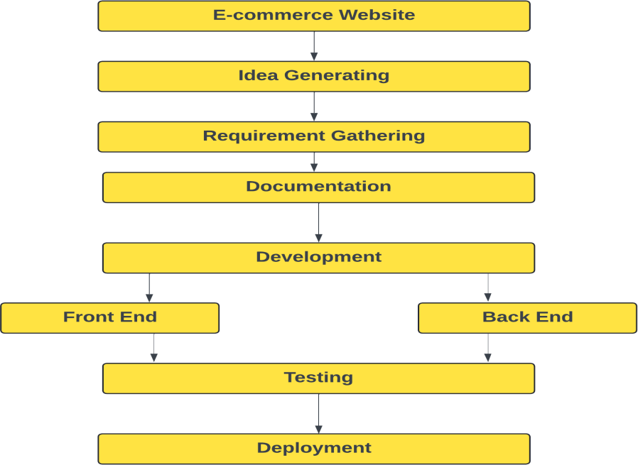

#### Project Estimation

In the development of a cafe and restaurant management system, accurate project estimation plays a crucial role in ensuring successful and timely completion within available resources. Here's a detailed breakdown of key considerations for project estimation:

###### Project Scope:

* The Online Cafe and Restaurant Management System is designed to cover a wide range of essential features, including interactive menu browsing, secure user registration and login, order placement and tracking, and integrated billing and payment functionalities

###### Team Size:

* The project is being developed by a solo developer, who is responsible for all major roles—front-end development, back-end development, database design and management, UI/UX design, and quality assurance. This approach ensures full control over the development process but also demands effective time management, multitasking abilities, and a strong grasp of full-stack web development.

###### Complexity:

* The overall complexity of the project is categorized as moderate to high. This stems from the integration of dynamic features such as real-time order status updates, secure login and role-based access, live chat functionality using SignalR, and asynchronous data handling using jQuery and Ajax. Additional layers of complexity are introduced through features like user feedback analysis, CAPTCHA implementation, and multi-tier CRUD operations involving stored procedures.

###### Technology Stack:

* The Online Cafe and Restaurant Management System is developed using ASP.NET Core MVC for building a scalable and modular web application structure. The frontend is styled and made responsive using Bootstrap, while jQuery handles dynamic content updates and Ajax-based interactivity. SQL Server serves as the backend database, supporting secure data storage and management through stored procedures. C# is used for server-side logic, ensuring robust processing of user inputs, business rules, and database interactions. Additionally, SignalR is integrated for real-time communication features like live chat, enhancing user engagement.

###### Testing and Quality Assurance:

* + Given the criticality of delivering a flawless user experience, a significant portion, approximately 20% of the development timeline, is allocated to testing and quality assurance activities.
  + Rigorous testing ensures that the platform meets all functional and performance requirements before deployment.
  + This includes unit testing, integration testing, performance testing, security testing, and user acceptance testing.
  + Automated testing frameworks and continuous integration tools may be employed to streamline the testing process and improve overall product quality.

###### Third-party Integrations:

* + Integrating with third-party payment gateways and Electronic Health Record (EHR) systems is expected to consume approximately 10% of the development effort.
  + This integration process involves ensuring seamless communication between the e-commerce platform and external systems while maintaining data security and integrity.
  + API documentation and compatibility checks are crucial for successful integration, and thorough testing is necessary to verify functionality and data synchronization.

###### User Experience and User Interface:

* + A substantial portion, roughly 30% of the development timeline, is dedicated to crafting an exceptional user experience (UX) and user interface (UI).
  + The emphasis is on creating a visually appealing, intuitive, and responsive interface that enhances user engagement and fosters trust and loyalty among customers.
  + This involves conducting user research, creating wireframes and prototypes, iterating on designs based on feedback, and implementing best practices for usability and accessibility.
  + Front-end frameworks like React.js and Vue.js can facilitate the

development of dynamic and interactive user interfaces, while CSS preprocessors like Sass or Less can streamline styling and theming.

###### Calculation:

* + Testing and Quality Assurance: 20% of development time
  + Assuming a total development time of 100 hours, 20 hours will be allocated for testing and quality assurance activities.
  + Third-party Integrations: 10% of development time
  + Following the same assumption, 10 hours will be dedicated to integrating with third-party systems.
  + User Experience and User Interface: 30% of development time
  + Based on the total development time, 30 hours will be spent on designing and implementing an exceptional user experience and interface.
  + By meticulously considering these factors during project estimation, the development team can devise a realistic plan, allocate resources effectively, and mitigate potential risks, ultimately steering the e- commerce project towards successful fruition within the defined parameters

#### Risk identification, analysis and management:

###### Security Risks:

Ensuring the security of customer data and payment information to prevent breaches and potential legal consequences.

###### Compliance Risks:

Adhering to industry regulations and standards such as GDPR, PCI DSS to avoid penalties and legal issues.

###### Technical Risks:

Potential hardware or software failures, website crashes, data loss, and other technical challenges impacting site functionality.

###### Integration Risks:

Challenges in integrating the website with existing systems such as inventory management or CRM tools, requiring additional resources and expertise.

###### Scalability Risks:

Designing the website to handle increasing traffic and transaction volumes as the business grows.

###### Performance Risks:

Ensuring fast loading times, smooth navigation, and minimal downtime to provide an optimal user experience.

###### User Adoption Risks:

Designing an intuitive user interface and implementing effective marketing strategies to encourage user adoption and engagement.

###### Budget and Schedule Risks:

Managing changes in project scope, unexpected delays, and cost overruns to stay within budget and meet deadlines.

###### Risk Identification:

Potential risks and challenges that may arise during the development of a health management system:

* Security Risks: Patient data privacy and security must be maintained at all times. A security breach could result in legal and financial liabilities.
* Compliance Risks: The system must be designed to comply with relevant regulations and standards. Non-compliance could result in legal and financial penalties.
* Technical Risks: Technical risks can include hardware and software failures, system crashes, data loss, and other technical issues that can impact the system's functionality and stability.
* Integration Risks: Integration with other systems can be challenging and may require additional resources and expertise.
* Scalability Risks: The system must be designed to scale to handle increasing volumes of users and data.
* Performance Risks: The system must be designed to perform efficiently, with fast response times and minimal downtime.
* User Adoption Risks: The system must be designed to be user-friendly and intuitive to encourage user adoption. Poor user adoption can result in low utilization rates and impact the success of the system.
* Budget and Schedule Risks: Changes in project scope, unexpected delays,

and other unforeseen circumstances can impact on the project budget and timeline.

###### Risk Analysis and Mitigation Strategies:

1. **Security Breaches:**

Probability: High, Impact: High

Mitigation: Implement robust security measures such as encryption, multi-factor authentication, and regular security audits. Conduct employee training on security protocols to mitigate risks**.**

###### Non-Compliance with Regulations and Standards:

Probability: Medium, Impact: High

Mitigation: Ensure system design aligns with relevant regulations and standards. Conduct regular compliance audits and promptly address any compliance issues to mitigate risks.

###### Technical Issues:

Probability: Medium, Impact: Medium

Mitigation: Implement a rigorous testing and quality assurance process to identify and address technical issues promptly. Regularly monitor system performance and stability to mitigate risks effectively.

###### Integration Challenges:

Probability: High, Impact: Medium

Mitigation: Collaborate closely with third-party vendors to define integration requirements clearly. Conduct comprehensive testing of integrations to identify and resolve issues promptly, reducing risks associated with integration challenges.

###### Scalability Challenges:

Probability: Medium, Impact: High

Mitigation: Design the system with scalability in mind, ensuring it can

accommodate increasing user volumes and data loads. Regularly monitor system performance to identify and address scalability issues, minimizing associated risk.

###### User Adoption Challenges:

Probability: Low, Impact: High

Mitigation: Conduct thorough user research to understand user needs and preferences. Design a user-friendly system and provide comprehensive user training and support to encourage user adoption and mitigate associated risks effectively.

###### Budget and Schedule Overruns:

Probability: Medium, Impact: Medium

Mitigation: Establish a realistic budget and timeline, regularly monitoring progress against milestones. Promptly identify and address any issues that could impact the project's budget or timeline to mitigate risks associated with budget and schedule overruns.

###### Risk management:

1. Identify Risks: Recognize potential risks like security breaches, compliance issues, technical glitches, integration complexities, scalability constraints, user adoption hurdles, and budget/schedule deviations.
2. Assess Risks: Evaluate the likelihood and impact of each risk, prioritizing them based on their potential effect on the website's functionality.
3. Develop Mitigation Strategies: Devise strategies to mitigate the impact of identified risks, aiming to minimize their effect on the website's operations.
4. Implement Mitigation Strategies: Put into action the mitigation plans formulated in step 3, continuously monitoring their effectiveness and making adjustments when needed.
5. Monitor and Evaluate Risks: Regularly observe and assess risks during the development phase, addressing any new risks that emerge promptly.
6. Establish a Risk Management Plan: Draft a comprehensive risk management plan delineating the actions to be taken to handle risks throughout the e-

commerce website development process. Review and update the plan regularly to ensure its relevance.

1. Train Employees: Educate employees on the risk management plan and protocols to enhance their awareness of potential risks and equip them with the necessary knowledge to respond effectively to any unforeseen events.

## System requirement study:

#### User Characteristics:

In the context of an Online Cafe and Restaurant Management System, the users of the platform are classified based on their roles and responsibilities. Each user group interacts with the system differently and requires specific functionalities to meet their needs. However, some of the key user characteristics can include:

* Admin:

Admins are responsible for overseeing the overall operations of the system and maintaining data integrity. They have complete control over backend functionalities, including managing user accounts, menu items, pricing, inventory, order processing, and staff information. Admins are typically tech-savvy and capable of managing database-related tasks using the ASP.NET Core MVC interface connected to SQL Server. They also handle customer queries, monitor system performance, generate reports, and ensure security protocols are in place to protect sensitive information. Admins use the dashboard to approve user registrations, review feedback, and manage content dynamically.

* Customers:

Customers are the primary users of the platform who access the system to browse menus, place orders, provide feedback, and make payments. These users may vary in demographics, preferences, and ordering behavior—from casual visitors looking to explore food options to returning customers interested in specific menu items or discounts. Customers expect a smooth, intuitive interface with clear menu categorization, secure payment options, order tracking, and personalized services. They interact with the system through user-friendly interfaces built with jQuery and Bootstrap, providing convenience for both desktop and mobile users.

* Staff:

Staff members interact with the platform to view and process orders, manage table reservations, update order status (e.g., preparing, ready, delivered), and coordinate with the kitchen team. Depending on the role, waiters may use the system to assign orders to tables, while kitchen staff may use it to view incoming orders in real time. The system helps streamline internal communication, reduce errors, and ensure timely service delivery. Their interface is simplified to focus on order status updates and inventory usage tracking.

#### Functional Requirements:

###### Admin:

* + User Management: The admin should be able to manage all user accounts, including customers and staff. This includes creating, modifying, approving, and deleting users, assigning user roles (e.g., customer, kitchen staff, delivery staff), and managing access permissions.
  + Menu Management: Admins must be able to add, edit, or delete menu items. This includes uploading food images, setting item descriptions, categorizing items (e.g., beverages, main course), managing pricing, and updating availability status.
  + Order Management: Admins should have the capability to monitor and manage all incoming customer orders, update order statuses process refunds if necessary, and generate order history and sales reports.
  + Content Management: Tools should be provided for the admin to manage website content such as home page banners, promotional offers, FAQs, terms and conditions, and customer support contact information.
  + Analytics and Reporting: Access to real-time dashboards and reporting features to analyze total orders, top-selling items, peak order times, customer activity, and feedback ratings. These insights help improve operations and marketing strategies.

###### Customer:

* + Account Registration and Login: Users can register, log in securely, update their profiles, and manage their passwords. Email or mobile verification may be included.
  + Menu Browsing and Ordering: Customers can view categorized menus with images, descriptions, and prices. They should be able to add items to the cart, customize their orders (e.g., quantity, notes), and place orders for delivery or pickup.
  + Order Tracking: Users should be able to track their current order status in real time, view past orders, and repeat previous orders with a single click.
  + Payment Integration: Secure payment gateways should allow users to pay online using multiple options (e.g., cards, UPI, wallet). Option for cash on delivery (COD) may also be included.
  + Feedback and Rating: Customers can submit feedback and rate individual menu items or their overall order experience, helping the restaurant improve service quality.
  + Live Chat : If implemented, users should be able to chat with support or the admin in real-time for queries related to orders, delivery, or payments.

#### Non-Functional Requirements:

* + Security: Ensure secure transmission of sensitive information through encryption and data protection measures.
  + Performance: The website should be fast, responsive, with quick page load times, smooth navigation, and minimal latency during transactional processes.
  + Usability: User-friendly interface with intuitive layouts, clear labeling, and support for assistive technologies to enhance accessibility.
  + Reliability: The website should be reliable and available, with minimal downtime and robust error handling to prevent disruption of user experiences.
  + Compatibility: Compatibility with various devices and browsers to ensure a consistent experience across different platforms and screen sizes.

#### Software Requirements:

* + - Editor: Visual Studio Code (VS Code)
    - Frontend Framework: React.js
    - Backend Framework: Node.js with Express.js
    - Database: MongoDB
    - Additional Tools: Postman for API development and testing

#### Windows Specifications:

* + - Operating System**:** Windows 11 Home Single Language
    - Version: 22H2

#### Hardware Requirements:

* + - Processor: Intel(R) Core(TM) i5 7th Generation CPU
    - RAM: 8.00 GB (7.77 GB usable)
    - System Type: 64-bit operating system, x64-based processor

# System Analysis:

###### Study of the Current System:

* + - In the system analysis phase, it's imperative to delve into understanding the existing processes comprehensively.
    - This involves studying current operations, including product management, order processing, and customer service handling.
    - We analyze existing data, such as sales records and customer feedback, to glean insights. Engaging with stakeholders like administrators, sellers, and customers aids in understanding their needs and expectations.
    - We assess our current technology stack to ascertain its adequacy or identify areas for upgrades. Conducting a SWOT analysis helps identify strengths, weaknesses, opportunities, and threats, laying the groundwork for designing an effective new e-commerce platform.

###### Problems in the Current System:

* + - Users encounter various challenges within the current system, impeding their experience.
    - These include difficulty finding specific products due to limited search options, sluggish loading times on certain pages, and lack of clear guidance during checkout.
    - Account management issues, like password resets and profile updates, contribute to user frustration and dissatisfaction. Addressing these issues is vital to improving user satisfaction and encouraging repeat visits and purchases.

###### Requirements of the New System:

* + - The new e-commerce platform must rectify existing shortcomings and meet user needs effectively.
    - It should feature enhanced search functionality with filters and sorting options, along with optimized performance for faster loading and smooth navigation.
    - A streamlined checkout process with clear instructions and simplified account management functionalities is essential. Responsive design ensures consistency across devices, while robust security measures protect user data.
    - Personalized product recommendations and comprehensive reporting tools enhance user engagement and business insights.
    - Seamless integration with third-party tools streamlines operations, while ongoing support ensures sustained user satisfaction.

###### Functions of the System - Use Case Diagram:

* + - A use case diagram illustrates the system's functions and interactions between users and the platform.
    - It outlines key functions like user registration, product search, adding items to the cart, checkout, account management, and order history viewing.
    - Admin functions encompass managing product listings, processing orders, generating reports, and overseeing user accounts.
    - Sellers interact with the system through tasks like product management, inventory control, order processing, and customer communication.

###### 4.5 . Features of the New System:

* The new system will boast an intuitive user interface for seamless navigation and accessibility.
* Advanced search capabilities, a streamlined checkout process, and personalized recommendations enhance user experience.
* Robust security measures ensure data protection, while comprehensive reporting tools provide valuable business insights.
* Integration with third-party services optimizes operations, and ongoing support ensures system reliability and user satisfaction.
* These features collectively contribute to a user-friendly, efficient, and secure e- commerce platform meeting user and business needs effectively.

###### Feasibility Study:

A feasibility study is imperative to assess the practicality and viability of implementing the proposed e-commerce platform. It evaluates various aspects, including technical, economic, operational, and scheduling considerations, to determine if the project is feasible.

* + 1. **Technical Feasibility:**
       - Existing Technology Evaluation: Assess the compatibility of the proposed technology stack (React.js, Node.js with Express.js, MongoDB) with the project requirements.
       - Resource Availability: Determine if the required hardware and software resources are readily accessible or if any upgrades or acquisitions are necessary.
       - Scalability: Evaluate the scalability of the chosen technology stack to accommodate future growth and expansion of the platform.
    2. **Economic Feasibility:**
       - Cost-Benefit Analysis: Conduct a cost-benefit analysis to compare the projected costs of development, implementation, and maintenance against the anticipated benefits and potential revenue generation.
       - Return on Investment (ROI): Estimate the ROI based on projected revenue streams, cost savings, and other financial metrics to ensure the project's profitability.
    3. **Operational Feasibility:**
       - User Acceptance: Assess the willingness and readiness of stakeholders, including administrators, sellers, and customers, to adopt and utilize the new e-commerce platform.
       - Training and Support: Evaluate the feasibility of providing necessary training and ongoing support to users to ensure effective utilization of the platform.
    4. **Scheduling Feasibility:**
       - Timeline Assessment: Evaluate the proposed project timeline against available resources, constraints, and dependencies to determine if the project can be completed within the desired timeframe.
       - Risk Management: Identify potential risks and develop mitigation strategies to address any challenges that may arise during the project's execution.

**Conclusion:**

Based on the findings of the feasibility study, it is determined that the proposed e- commerce platform is technically feasible, economically viable, operationally feasible, and can be completed within the specified schedule with proper risk management measures in place. Therefore, moving forward with the development and implementation of the platform is recommended.

# System Design:

* A Functional and behavior modelling:
  1. **Data flow diagram:**

##### Context level DFD:

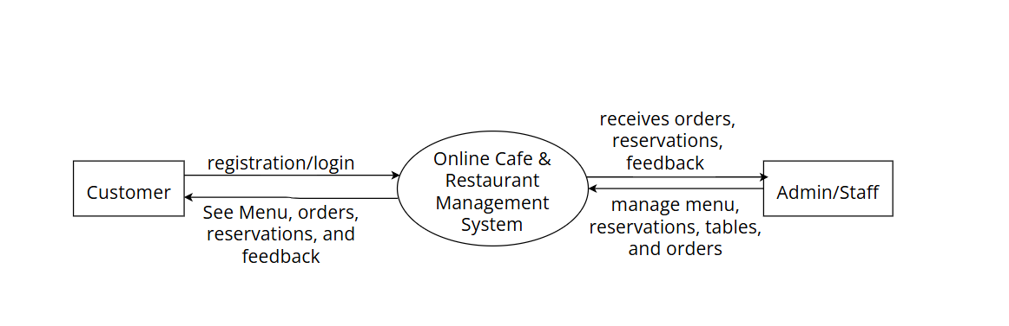

27

1. First level DFD:
   * Admin module:

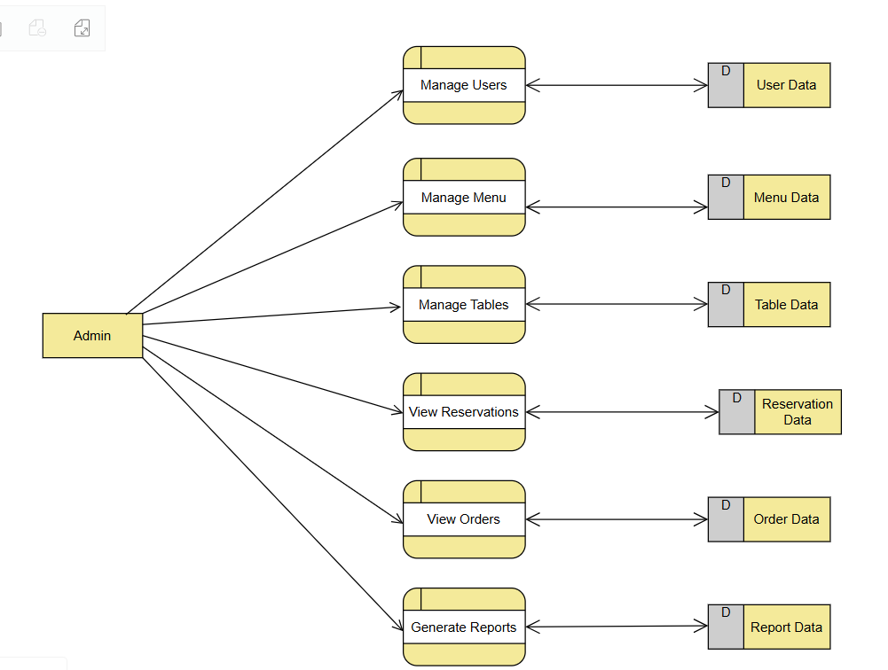

28

* + Staff module:

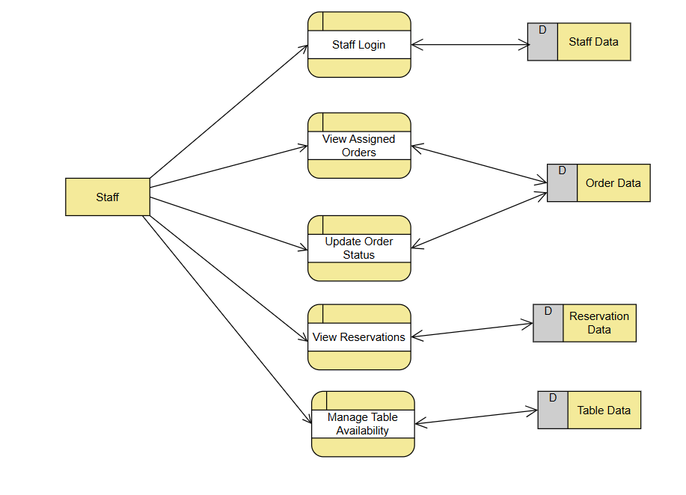

* Customer Module

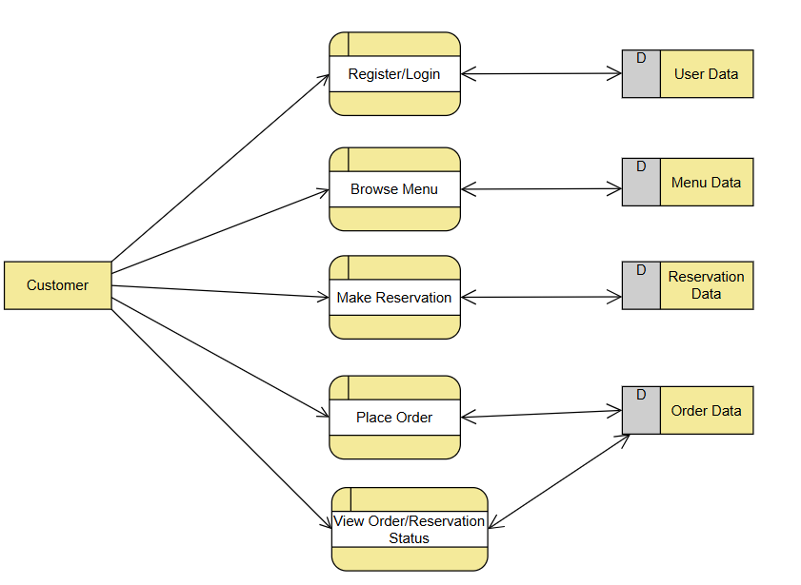

* 1. **UML diagram:**
     + Use Case diagram- Admin module

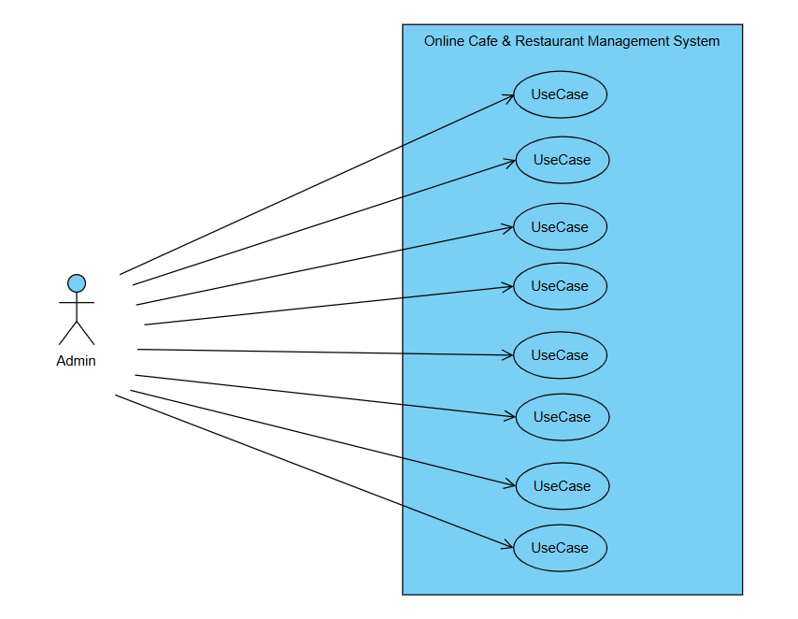

31

* + - Use case diagram- Staff module:

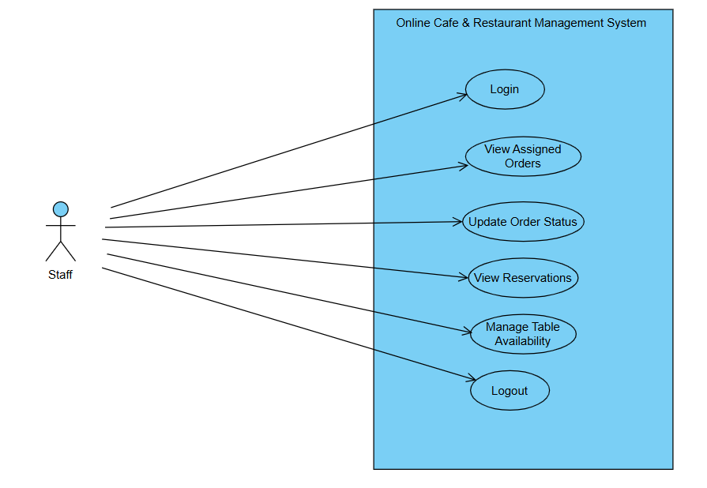

* + - Use Case Diagram :Customer Module

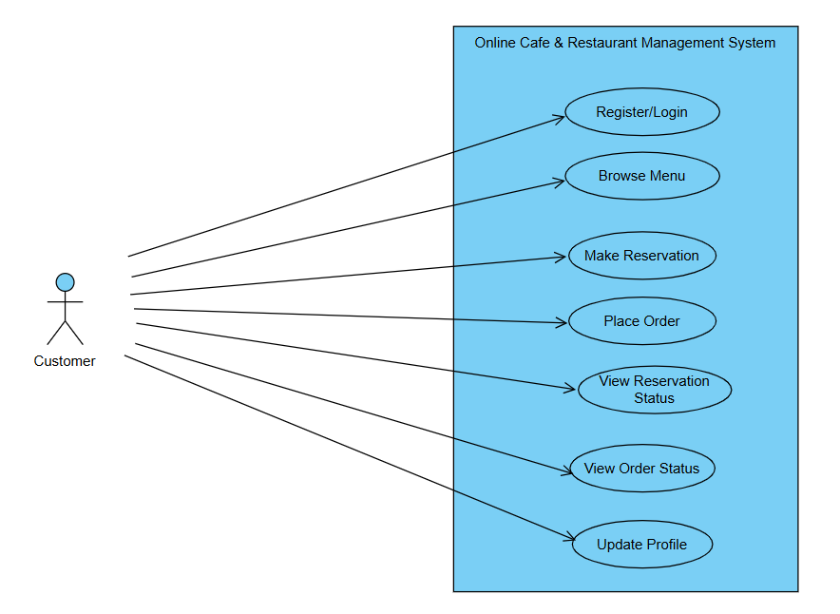

* 1. **Entity relationship diagram:**

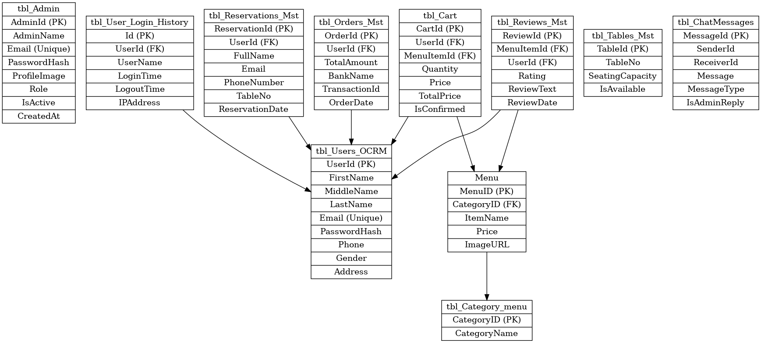

## Data Dictionary

* **Admin**

|  |  |  |  |
| --- | --- | --- | --- |
| **Field Name** | **Data Type** | **Description** | **Constraints** |
| AdminId | INT | Unique admin ID | Primary Key, Identity |
| AdminName | NVARCHAR(100) | Admin full name | NOT NULL |
| Email | NVARCHAR(100) | Admin email | NOT NULL, Unique |
| PasswordHash | NVARCHAR(255) | Hashed password | NOT NULL |
| ProfileImage | NVARCHAR(255) | Profile image URL/path | NULLf |
| Role | NVARCHAR(50) | Admin role | DEFAULT 'SuperAdmin' |

* **Customer**

|  |  |  |  |
| --- | --- | --- | --- |
| **Field Name** | **Data Type** | **Description** | **Constraints** |
| UserId | BIGINT | Unique user ID | Primary Key, Identity |
| FirstName | NVARCHAR(50) | First name | NOT NULL |
| MiddleName | NVARCHAR(50) | Middle name | NOT NULL |
| LastName | NVARCHAR(50) | Last name | NOT NULL |
| ProfileImage | NVARCHAR(255) | Profile image | NULL |
| Address | NVARCHAR(255) | Address | NOT NULL |
| CountryId | BIGINT | Country ID | NULL |
| StateId | BIGINT | State ID | NULL |
| CityId | BIGINT | City ID | NULL |
| Phone | NVARCHAR(15) | Phone number | NOT NULL |
| Gender | NVARCHAR(10) | Gender | NOT NULL |
| Email | NVARCHAR(100) | Email | NOT NULL, Unique |
| PasswordHash | NVARCHAR(255) | Password hash | NOT NULL |
| Flag | NCHAR(1) | Status flag | NULL |
| CreateUser | BIGINT | Created by | NULL |
| CreateDate | DATETIME | Creation date | NULL |
| UpdateUser | BIGINT | Updated by | NULL |
| UpdateDate | DATETIME | Last update date | NULL |
| CaptchaCode | NVARCHAR(10) | Captcha code entered | NULL |
| CaptchaHashKey | NVARCHAR(100) | Encrypted captcha hash | NULL |
| CaptchaExpiry | DATETIME | Captcha expiration time | NULL |
| CaptchaStatus | NVARCHAR(10) | Captcha status | NULL |

* **User Login Histotry:**

|  |  |  |  |
| --- | --- | --- | --- |
| **Field Name** | **Data Type** | **Description** | **Constraints** |
| Id | BIGINT | Unique login ID | Primary Key, Identity |
| UserId | BIGINT | Foreign key to user | FK: tbl_Users_OCRM(UserId) |
| UserName | NVARCHAR(500) | Username | NOT NULL |
| LoginTime | DATETIME | Login time | DEFAULT GETDATE() |
| LogoutTime | DATETIME | Logout time | NULL |
| IPAddress | NVARCHAR(50) | IP address | NULL |
| UserAgent | NVARCHAR(500) | Browser info | NULL |
| Status | NVARCHAR(20) | Status | DEFAULT 'Active' |

* **Tables:**

|  |  |  |  |
| --- | --- | --- | --- |
| **Field Name** | **Data Type** | **Description** | **Constraints** |
| TableId | INT | Table ID | Primary Key, Identity |
| TableNo | NVARCHAR(10) | Table number | NULL |
| SeatingCapacity | INT | Seat count | NULL |
| IsAvailable | BIT | Availability | NULL |
| Flag | NCHAR(1) | Status flag | NULL |
| CreateUser | BIGINT | Created by | NULL |
| CreateDate | DATETIME | Creation date | NULL |
| UpdateUser | BIGINT | Updated by | NULL |
| UpdateDate | DATETIME | Update date | NULL |

* **Review :**

|  |  |  |  |
| --- | --- | --- | --- |
| **Field Name** | **Data Type** | **Description** | **Constraints** |
| ReviewId | INT | Review ID | Primary Key, Identity |
| MenuItemId | INT | Menu item ID | FK: Menu(MenuID) |
| UserId | BIGINT | User ID | FK: tbl_Users_OCRM(UserId) |
| Rating | INT | Rating 1–5 | CHECK (Rating between 1 and 5) |
| ReviewText | NVARCHAR(500) | Review content | NULL |
| ReviewDate | DATETIME | Review date | DEFAULT GETDATE() |

* **Reservation:**

|  |  |  |  |
| --- | --- | --- | --- |
| **Field Name** | **Data Type** | **Description** | **Constraints** |
| ReservationId | INT | Reservation ID | Primary Key, Identity |
| UserId | INT | Reserved by user ID | NULL |
| FullName | NVARCHAR(100) | Reserver's name | NOT NULL |
| Email | NVARCHAR(100) | Email | NOT NULL |
| PhoneNumber | NVARCHAR(20) | Phone number | NOT NULL |
| TableNo | NVARCHAR(10) | Table number | NULL |
| ReservationDate | DATETIME | Reservation date & time | NOT NULL |
| NumberOfGuests | INT | No. of guests | NOT NULL |
| SpecialRequest | NVARCHAR(500) | Special notes | NULL |
| Flag | NCHAR(1) | Status flag | NULL |
| CreateUser | BIGINT | Created by | NULL |
| CreateDate | DATETIME | Created date | NULL |
| UpdateUser | BIGINT | Updated by | NULL |
| UpdateDate | DATETIME | Updated date | NULL |

* **Chat:**

|  |  |  |  |
| --- | --- | --- | --- |
| **Field Name** | **Data Type** | **Description** | **Constraints** |
| MessageId | INT | Message ID | Primary Key, Identity |
| SenderId | INT | Sender user ID | NULL |
| ReceiverId | INT | Receiver user ID | NULL |
| Message | NVARCHAR(MAX) | Message content | NOT NULL |
| MessageType | NVARCHAR(50) | Type (text/image) | NOT NULL |
| IsAdminReply | BIT | Admin reply status | DEFAULT 0 |
| IsRead | BIT | Read status | DEFAULT 0 |
| SentOn | DATETIME | Sent date | DEFAULT GETDATE() |

* **Category Menu:**

|  |  |  |  |
| --- | --- | --- | --- |
| **Field Name** | **Data Type** | **Description** | **Constraints** |
| CategoryID | INT | Category ID | Primary Key |
| CategoryName | NVARCHAR(100) | Category name | NOT NULL |

* **Orders:**

|  |  |  |  |
| --- | --- | --- | --- |
| **Field Name** | **Data Type** | **Description** | **Constraints** |
| OrderId | INT | Order ID | Primary Key, Identity |
| UserId | INT | Customer ID | NOT NULL |
| TotalAmount | DECIMAL(18,2) | Total bill amount | NOT NULL |
| BankName | NVARCHAR(100) | Payment bank | NULL |
| TransactionId | NVARCHAR(100) | Transaction ID | NULL |
| OrderDate | DATETIME | Order date | DEFAULT GETDATE() |
|  |  |  |  |

* **Cart:**

|  |  |  |  |
| --- | --- | --- | --- |
| **Field Name** | **Data Type** | **Description** | **Constraints** |
| CartId | BIGINT | Cart ID | Primary Key, Identity |
| UserId | BIGINT | User ID | NULL |
| MenuItemId | BIGINT | Menu item ID | NOT NULL |
| Quantity | INT | Item quantity | NOT NULL |
| Price | DECIMAL(10,2) | Unit price | NULL |
| TotalPrice | DECIMAL(10,2) | Total price | NULL |
| IsConfirmed | BIT | Order confirmed | DEFAULT 0 |
| IsPaid | BIT | Payment status | DEFAULT 0 |
| AddedDate | DATETIME | Date added to cart | DEFAULT GETDATE() |

* **Menu:**

|  |  |  |  |
| --- | --- | --- | --- |
| **Field Name** | **Data Type** | **Description** | **Constraints** |
| MenuID | INT | Menu item ID | Primary Key, Identity |
| CategoryID | INT | Category ID | NOT NULL |
| ItemName | NVARCHAR(150) | Item name | NOT NULL |
| Description | NVARCHAR(255) | Description | NULL |
| Price | DECIMAL(10,2) | Item price | CHECK (Price > 0) |
| ImageURL | NVARCHAR(255) | Image path | NULL |
| Type | NVARCHAR(50) | Veg/Non-Veg | NULL |
| CreatedAt | DATETIME | Date added | DEFAULT GETDATE() |

# Implementation Environment :

###### Implementation Environment:

The implementation environment for the e-commerce platform encompasses both the development and deployment setups. It includes the necessary hardware, software, and network configurations to support the development, testing, and eventual deployment of the platform.

* Hardware Requirements:
* Development Server: A dedicated server for hosting the development environment, equipped with sufficient processing power and memory to support the development tasks.
* Testing Environment: A separate testing server to conduct thorough testing of the platform's functionalities and performance before deployment.
* Deployment Server: A production server capable of handling the anticipated traffic and workload of the live e-commerce platform.
* Software Requirements:
* Operating System: Linux-based operating system for servers, such as Ubuntu or CentOS, to provide a stable and secure environment.
* Web Server: Apache or Nginx web server to serve the e-commerce platform to users over the internet.
* Database Management System: PostgreSQL database management system to store and manage product data, user information, and transaction records.
* Development Tools: Integrated Development Environment (IDE) like Visual Studio Code or Sublime Text for coding and debugging, Git for version control, and Postman for API testing.
* Frameworks and Libraries: Node.js with Express.js for backend development, React.js for frontend development, and other necessary libraries and frameworks for additional functionalities.
* Network Configurations:
* Domain Name: A registered domain name for the e-commerce platform to provide a unique web address for users to access.
* SSL Certificate: Secure Socket Layer (SSL) certificate to encrypt communication between users' browsers and the server, ensuring data security.
* Firewall Configuration: Firewall rules to control incoming and outgoing network traffic, enhancing server security.
* Infrastructure:

The infrastructure for an e-commerce platform needs to be robust and scalable to support the demands of online retail operations. This includes both hardware and software components:

* Hardware:
* Servers, storage devices, and networking equipment must be selected to handle the expected traffic and workload of the e-commerce platform. This may involve deploying servers in a data center or using cloud-based infrastructure for flexibility and scalability.
* Software: Operating systems, databases, web servers, and other software components must be carefully chosen to ensure optimal performance, reliability, and security.
* This may include using Linux-based operating systems for servers, PostgreSQL for the database management system, and Apache or Nginx as the web server.
* Security:
* Security is paramount in e-commerce to protect customer data, financial transactions, and sensitive business information. The following security measures should be implemented:
* Encryption: Secure Socket Layer (SSL) encryption should be used to encrypt data transmitted between users' browsers and the server, preventing unauthorized access.
* Access Controls: Role-based access controls should be implemented to restrict access to sensitive information and administrative functions based on users' roles and permissions.
* Compliance: The e-commerce platform must comply with relevant regulations such as PCI DSS for payment card data security and GDPR for data protection and privacy.
* Integration:
* Integration with third-party services and systems is essential for seamless operations and enhanced functionality. This may include:
* ​
* Payment Gateways: Integration with payment gateways such as PayPal or Stripe for secure online transactions.
* Inventory Management Systems: Integration with inventory management systems to track product availability and manage stock levels.
* Shipping Providers: Integration with shipping providers for real-time shipping rates, label printing, and order tracking.
* Training:
* Training is crucial for ensuring that staff members can effectively use the e- commerce platform. This may involve:
* User Training: Training sessions for employees responsible for managing product listings, processing orders, and providing customer support.
* Administrator Training: Training for system administrators responsible for configuring and maintaining the e-commerce platform.
* Testing:
* Thorough testing is essential to identify and address any issues before the e- commerce platform is launched. This includes:
* Functional Testing: Testing the functionality of the platform to ensure that all features work as expected.
* Performance Testing: Testing the performance of the platform under different loads to ensure optimal speed and responsiveness.
* Security Testing: Testing the security of the platform to identify and address any vulnerabilities or weaknesses.
* Support and Maintenance:
* Ongoing support and maintenance are necessary to keep the e-commerce platform running smoothly. This may involve:
* ​
* Regular Updates: Applying software updates and security patches to ensure that the platform remains secure and up-to-date.
* Technical Support: Providing technical support to address any issues or concerns that arise during day-to-day operations.
* Monitoring: Monitoring the performance and security of the platform to identify and address any issues proactively.

###### Program / Modules Specification with Screenshots:

The e-commerce platform consists of several modules, each serving specific functions to ensure smooth operation and enhanced user experience. Below are the key modules along with their specifications and screenshots:

Customer Pages :

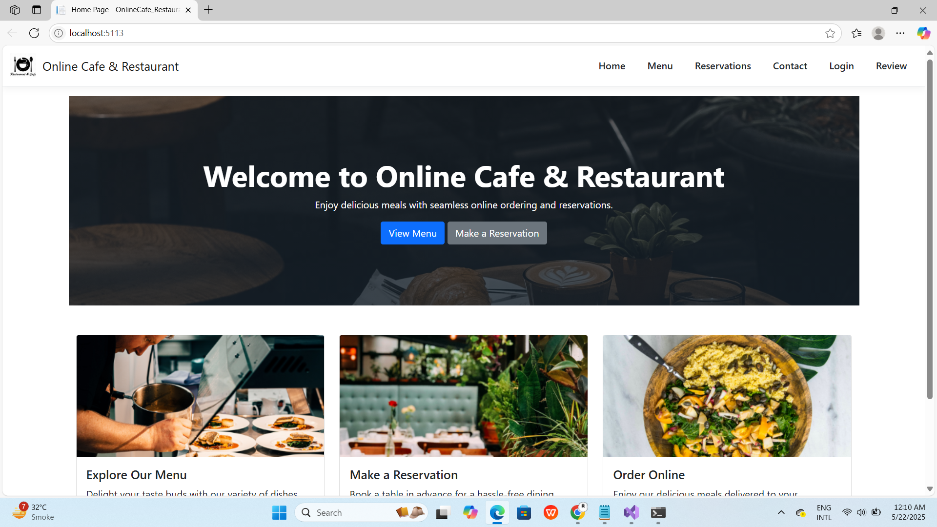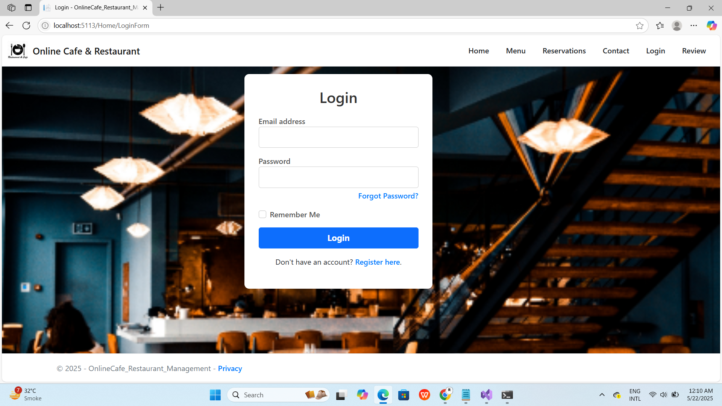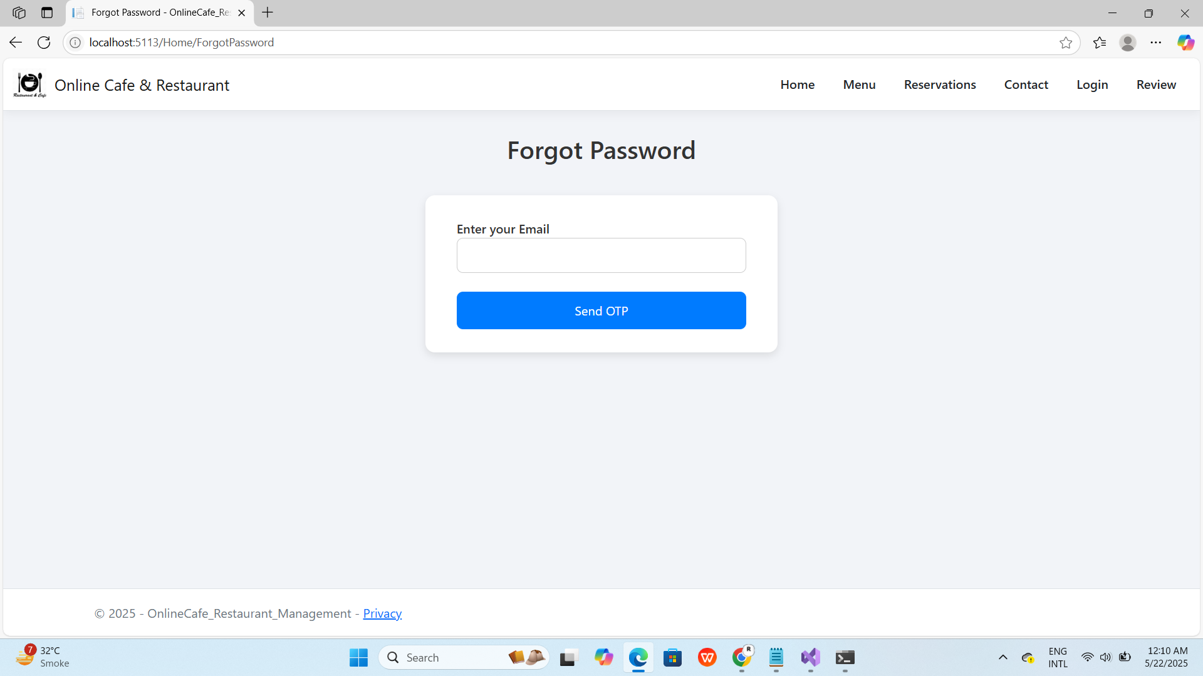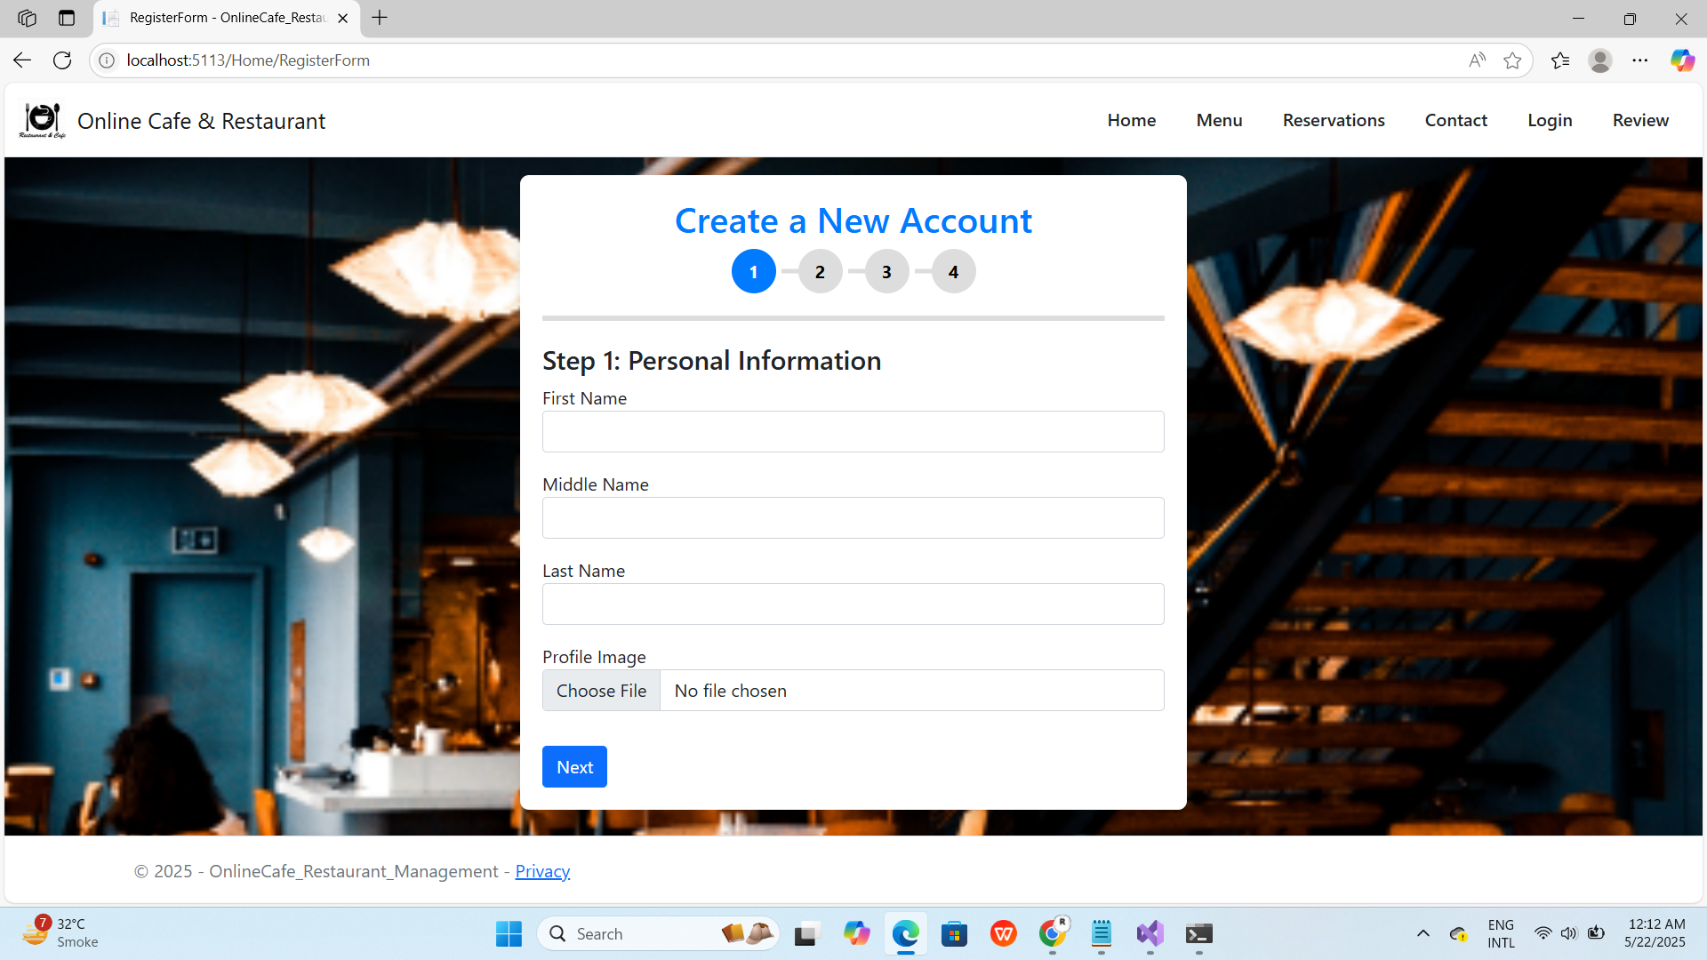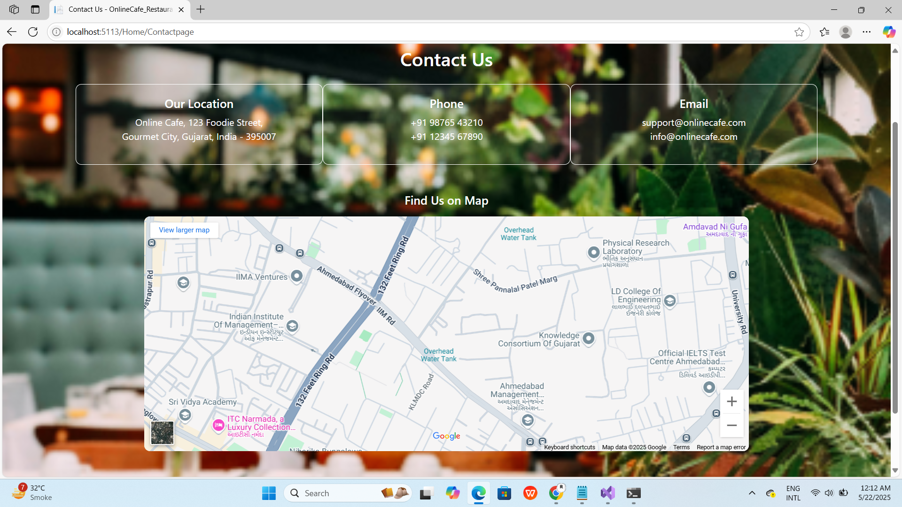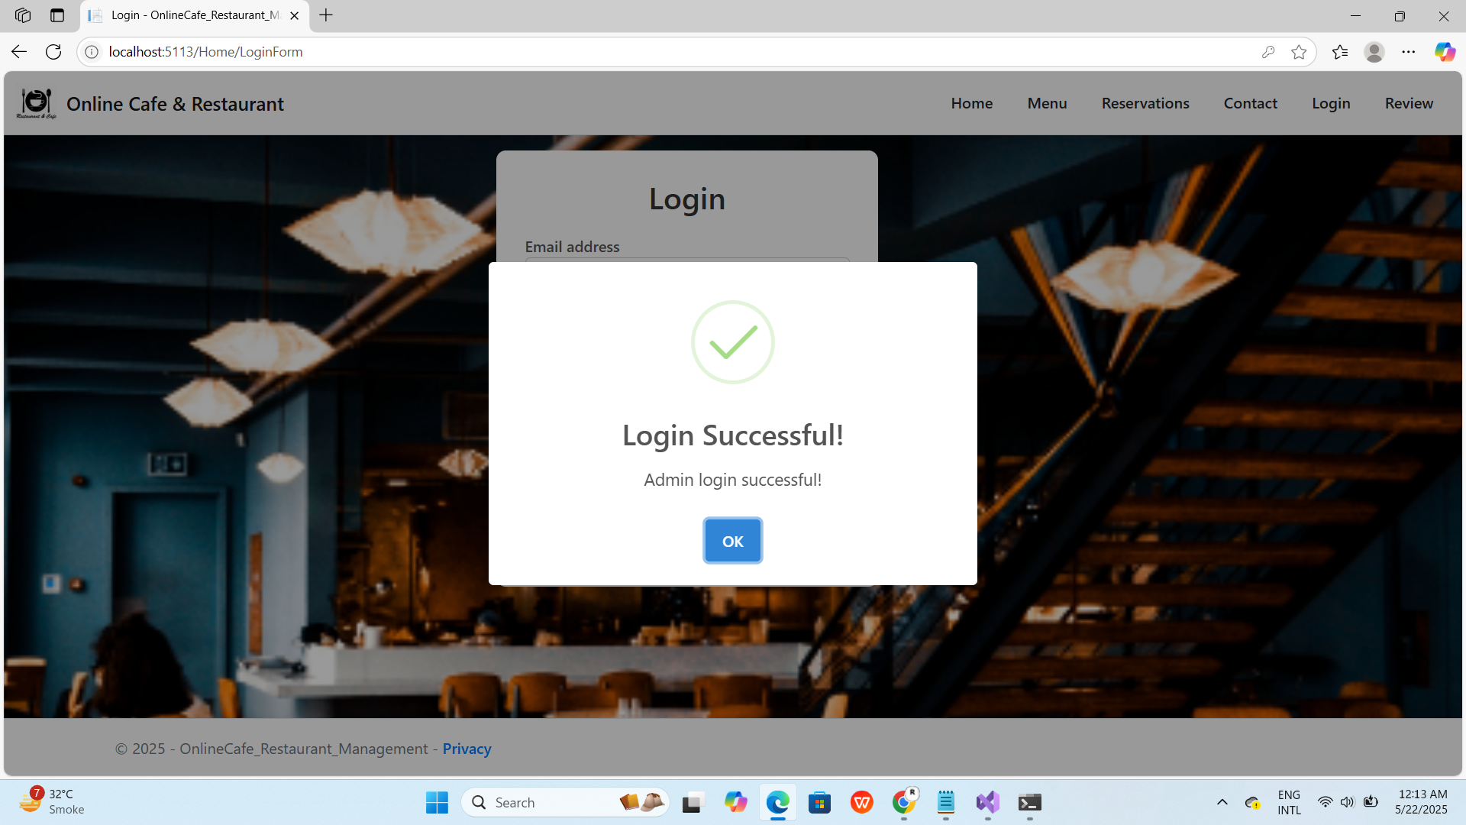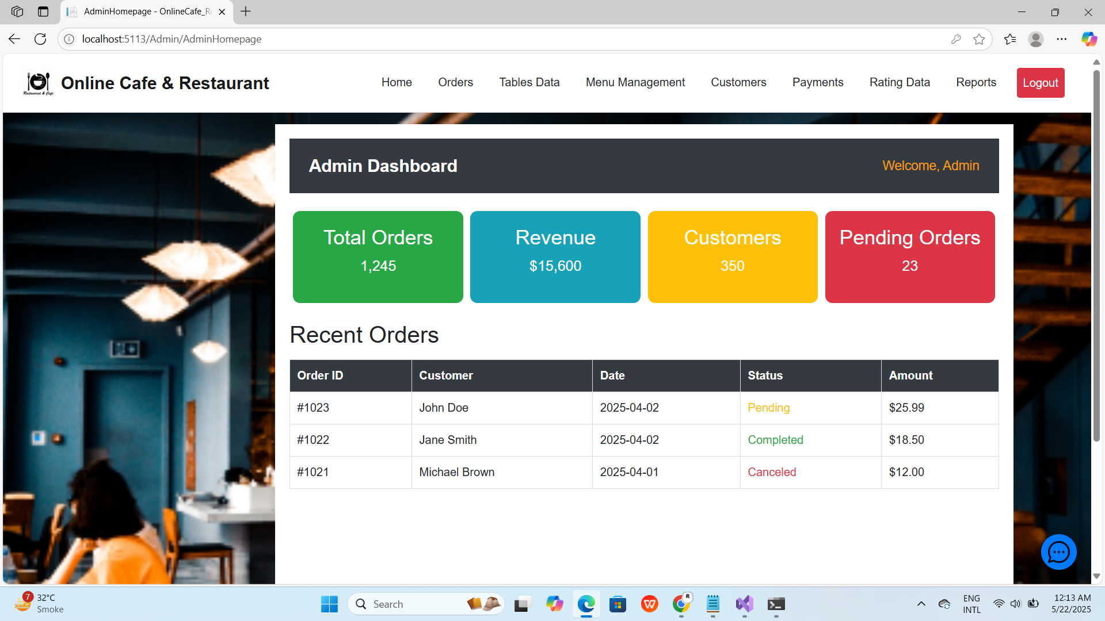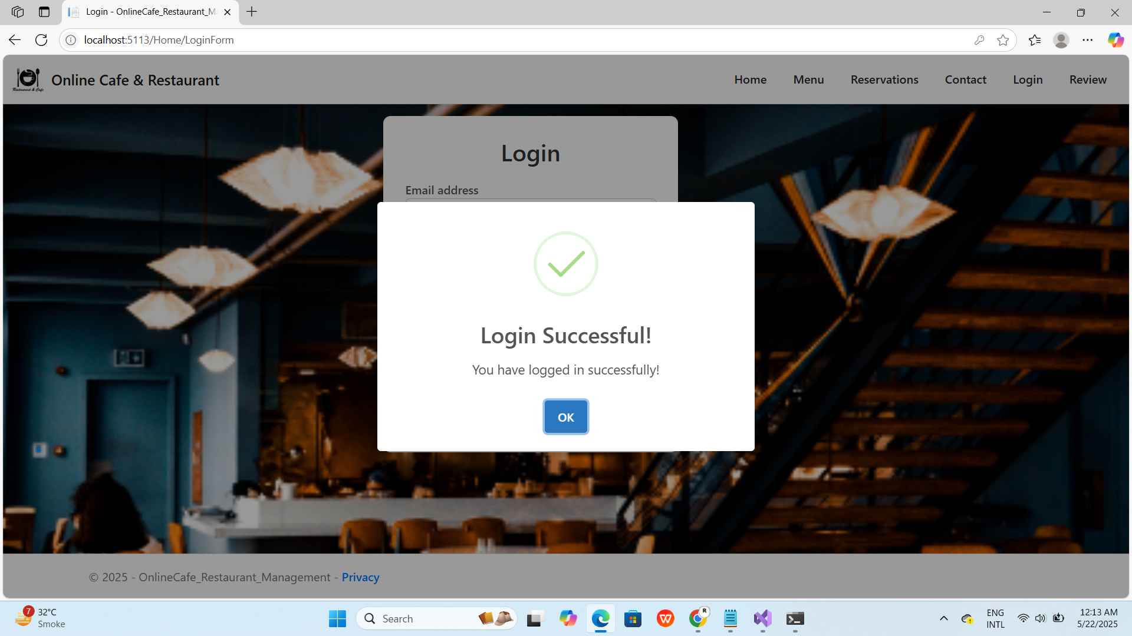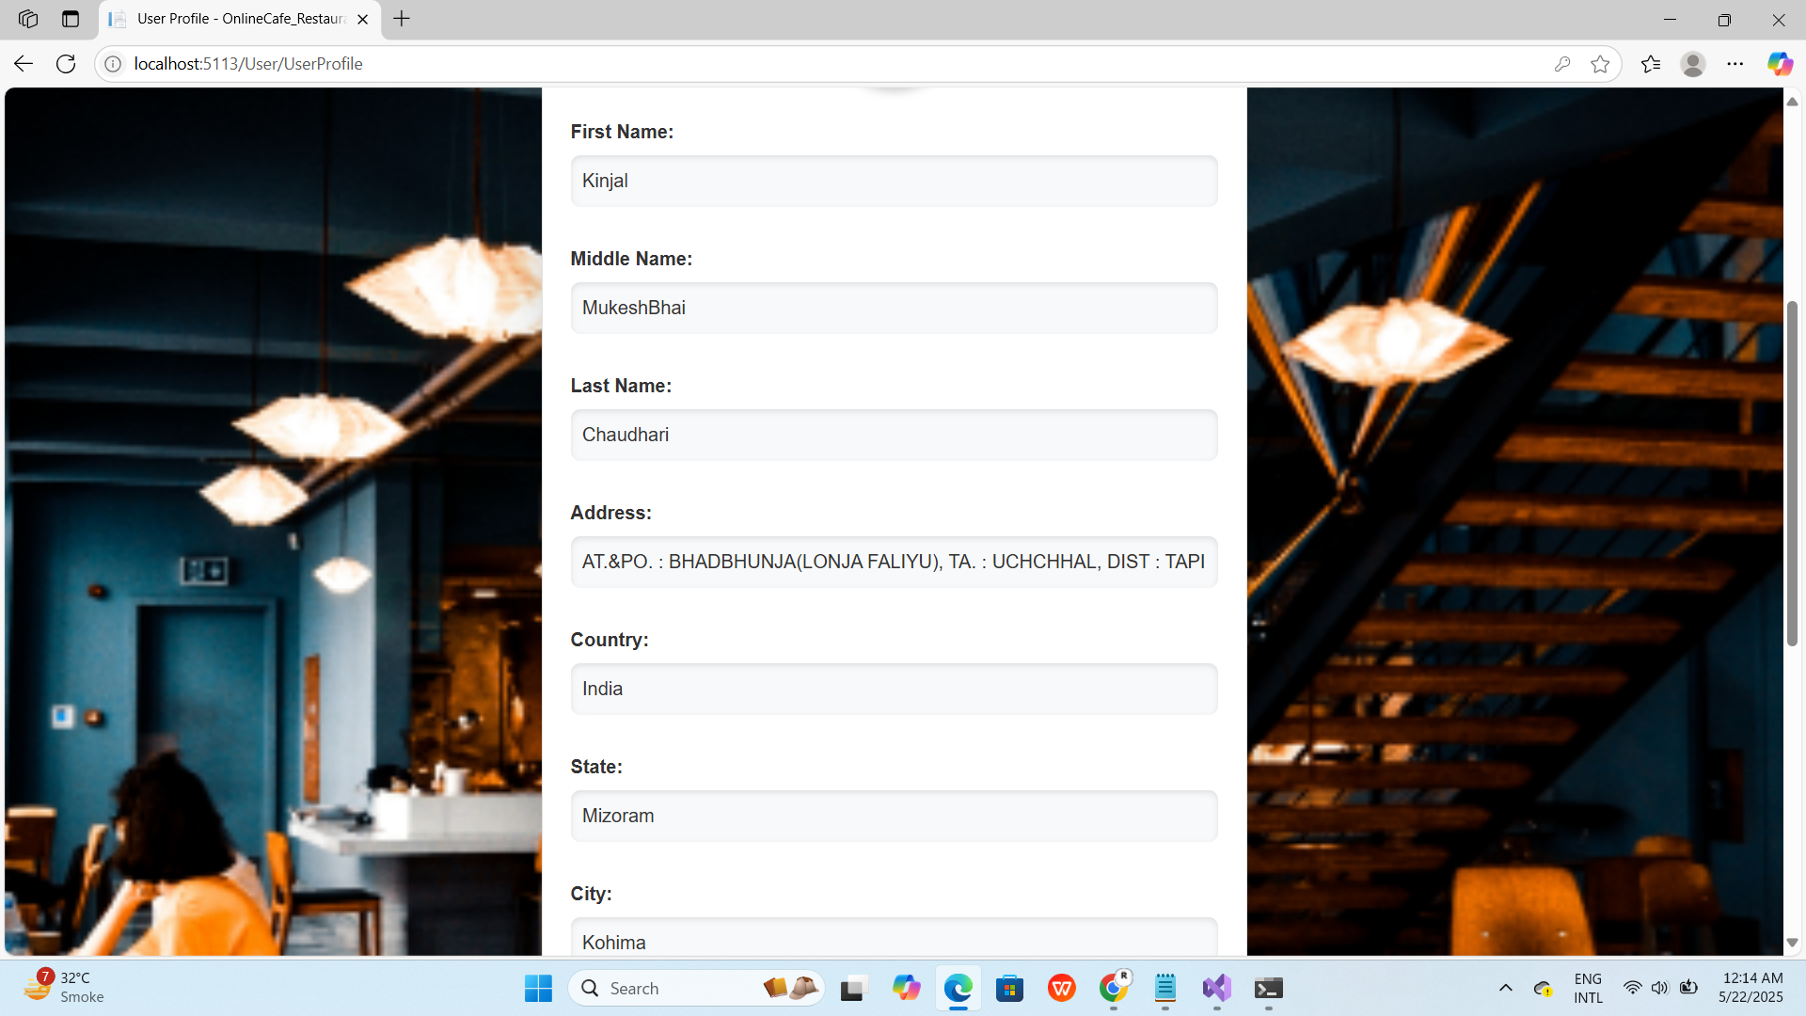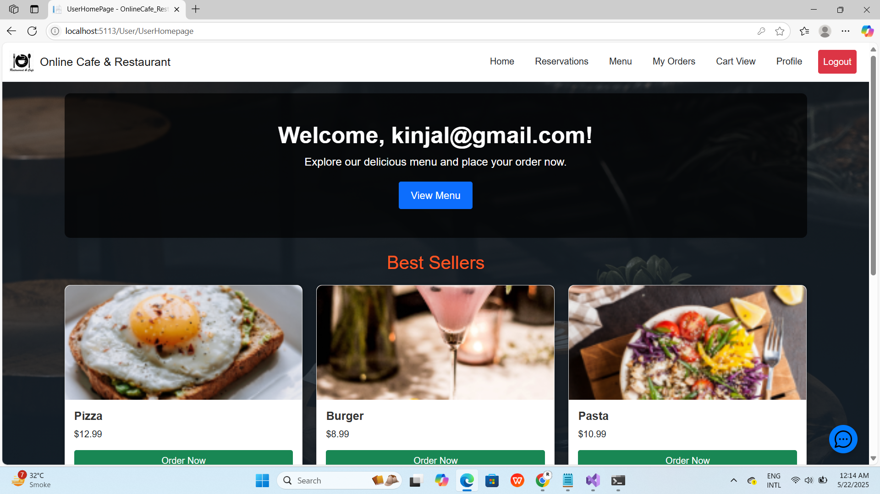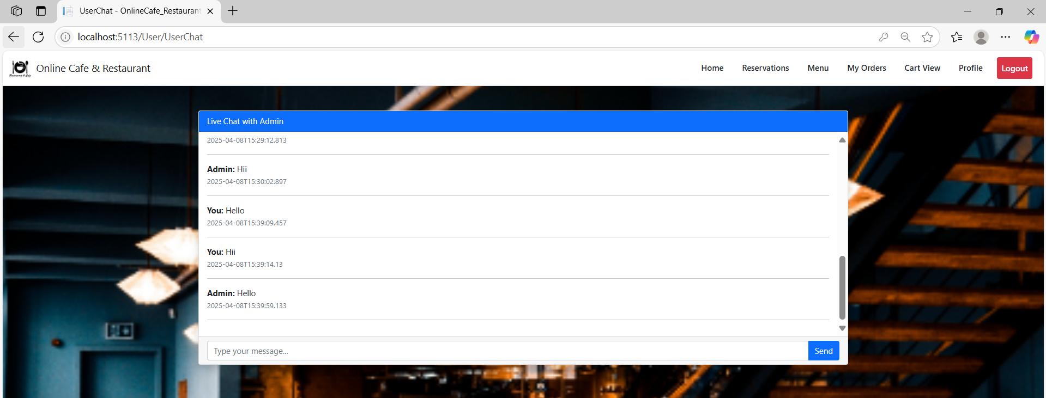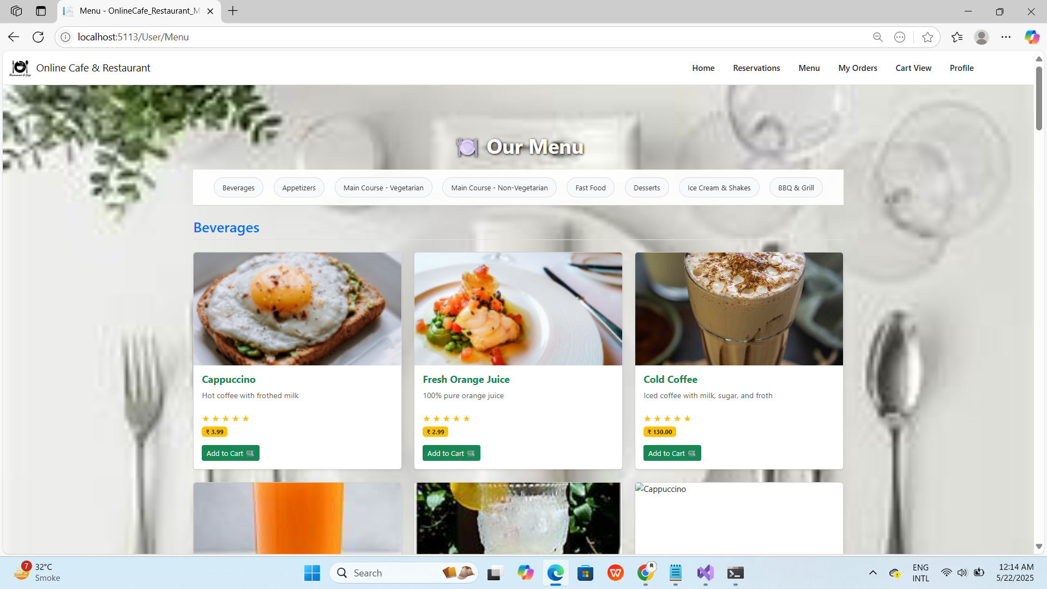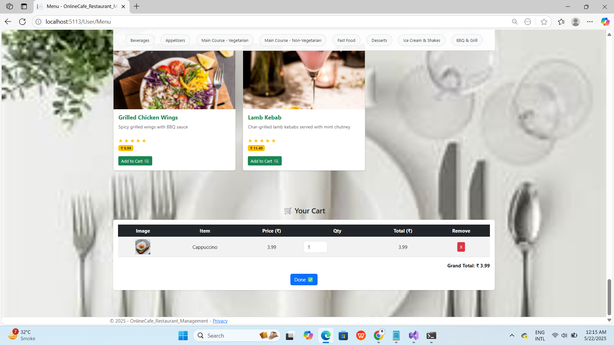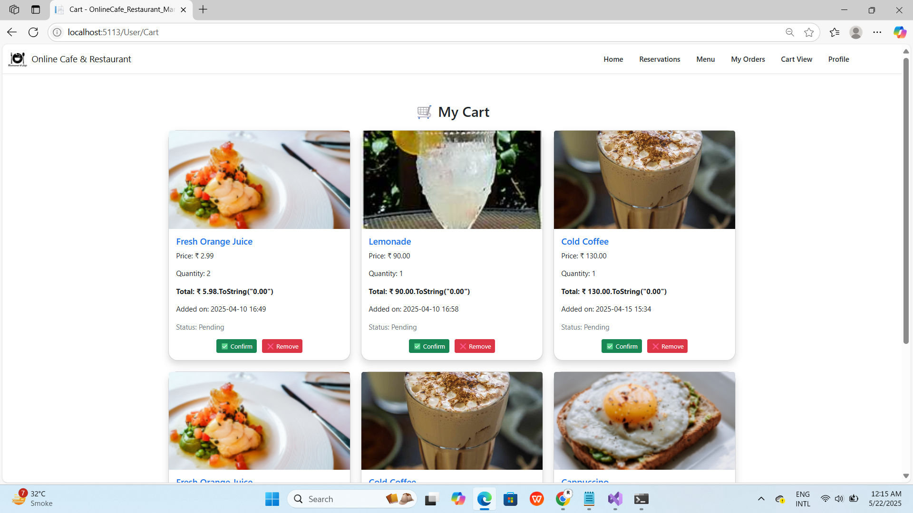

Admin Page

Seller Pages:

###### Security Features for an E-commerce Website:

* + - Secure Socket Layer (SSL) Encryption:

SSL encryption should be implemented to secure sensitive data such as payment information during transactions. This ensures that customer data remains confidential and protected from unauthorized access.

* + - Secure Payment Gateways:

Integration with secure payment gateways such as PayPal, Stripe, or Authorize.Net ensures that customer payment information is processed securely, reducing the risk of fraud or data breaches.

* + - Two-Factor Authentication (2FA):

Implementing 2FA adds an extra layer of security by requiring users to provide two forms of authentication, such as a password and a unique code sent to their mobile device, before accessing their accounts or making transactions.

* + - Regular Security Audits:

Conducting regular security audits and penetration testing helps identify vulnerabilities in the e-commerce website's infrastructure, codebase, and third-party integrations, allowing for timely remediation and strengthening of security measures.

* + - Fraud Detection and Prevention:

Utilizing advanced fraud detection algorithms and machine learning models can help identify and prevent fraudulent activities such as payment fraud, account takeover, and identity theft, safeguarding both the business and its customers.

* + - Secure Hosting Environment:

Hosting the e-commerce website on a secure and reliable hosting platform with robust security measures such as firewalls, intrusion detection systems, and regular backups ensures data integrity and availability, even in the face of cyber threats or server failures.

* + - Compliance with Data Protection Regulations:

Ensuring compliance with data protection regulations such as PCI DSS, GDPR, and CCPA is essential for protecting customer privacy and avoiding regulatory penalties. This includes implementing measures to securely store, process, and transmit

* + - User Account Security:

Encouraging users to use strong, unique passwords and providing options for account recovery and password reset mechanisms enhances user account security.

Additionally, implementing account lockout mechanisms and session management controls helps prevent unauthorized access to user accounts.

* + - Security Awareness Training:

Providing comprehensive security awareness training to employees and stakeholders involved in managing and maintaining the e-commerce website helps raise awareness about potential security risks and best practices for mitigating them, fostering a culture of security within the organization.

# Testing:

### Testing Plans:

###### Unit Testing:

Verify individual units like login or product registration modules to ensure they function correctly.

###### Integration Testing:

Assess how different components interact, such as checking how orders are processed and inventory is updated.

###### System Testing:

Evaluate the entire system against project requirements, covering all features and components.

###### Acceptance Testing:

Test the website against client/stakeholder requirements to confirm it meets their needs.

###### Security Testing:

Assess security features to safeguard customer data from cyber threats and unauthorized access.

###### Performance Testing:

Evaluate website performance under various loads to identify bottlenecks and ensure smooth operation.

###### Usability Testing:

Ensure the website is intuitive and easy to navigate for both merchants and customers.

### Testing Method:

###### Black Box Testing:

* Test without knowledge of internal workings, focusing on inputs and outputs.
* Identify incorrect functions, interface errors, data structure issues, etc.
* Steps include requirement identification, scenario creation, test case definition, execution, defect reporting, and result documentation.

###### White Box Testing:

* Investigate internal logic and code structure.
* Understand code workings to choose inputs and validate outputs.
* Steps involve code understanding, key area identification, test case development, execution, debugging, retesting, and result reporting. 61

### Test Cases:

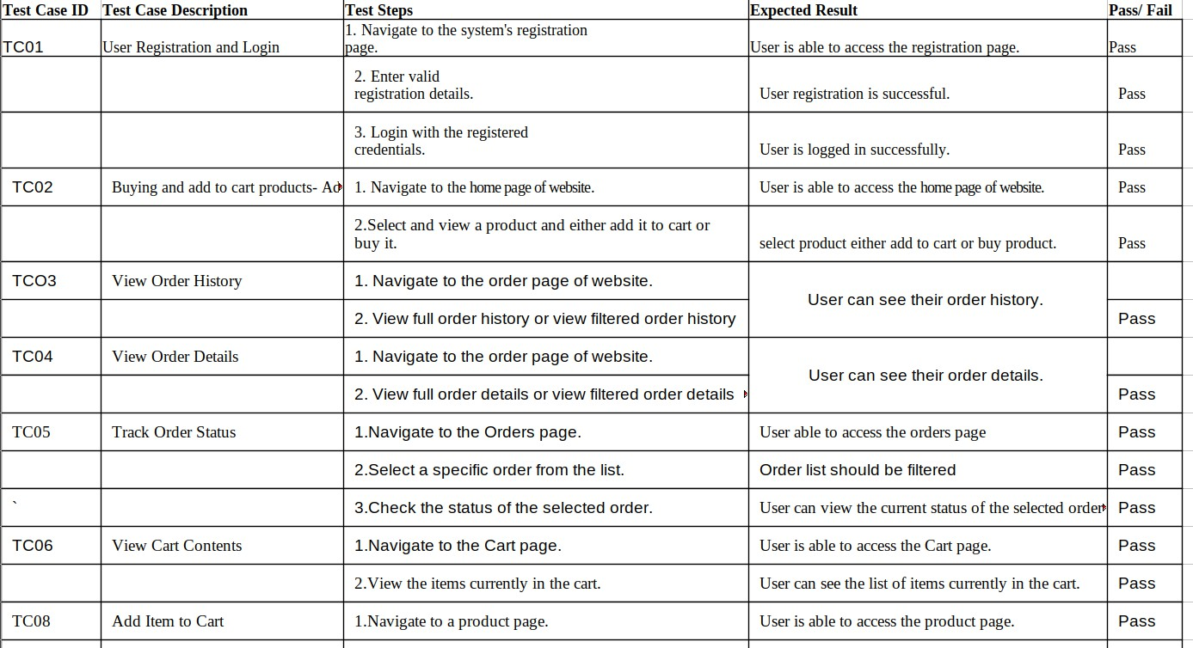

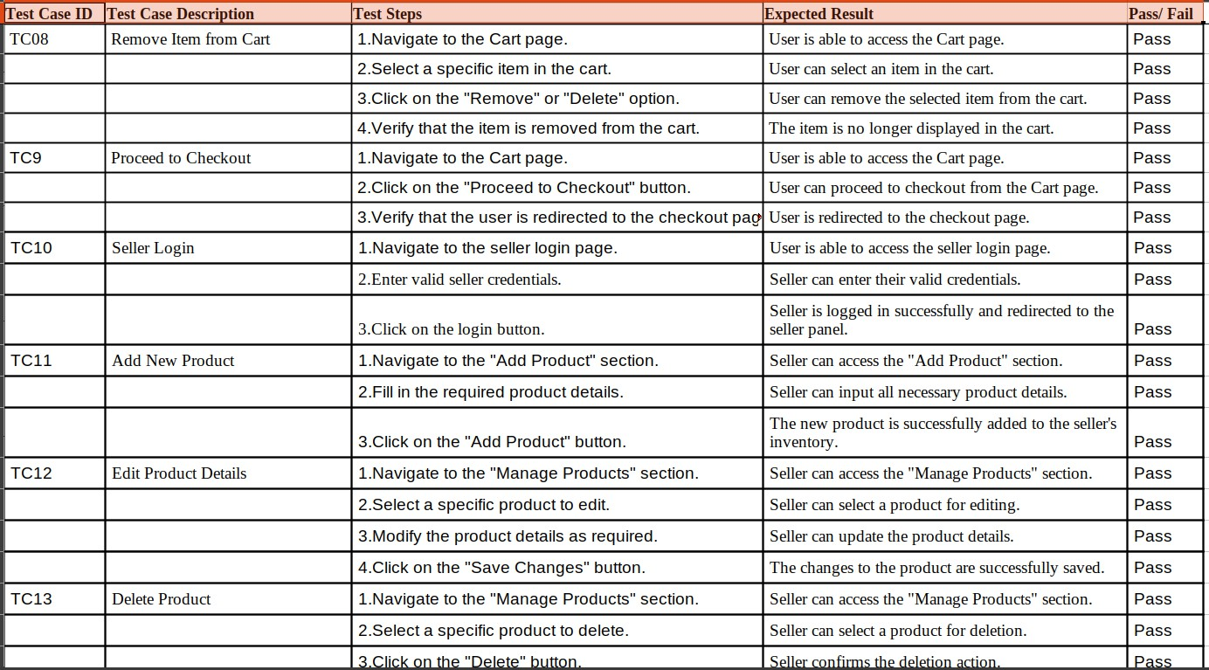

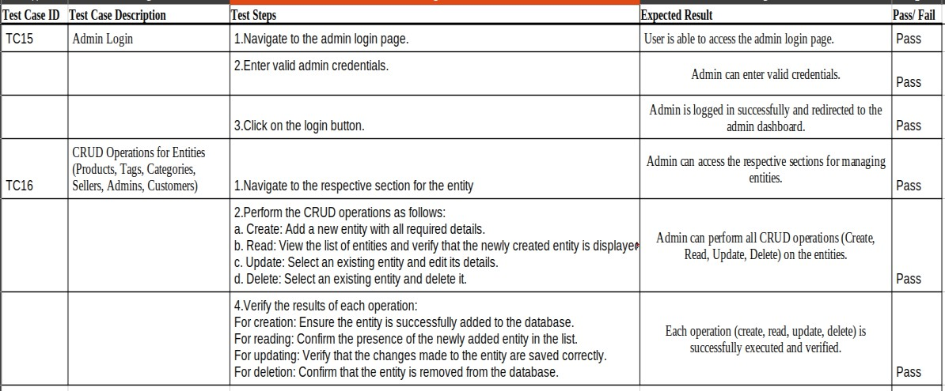

* Test Report

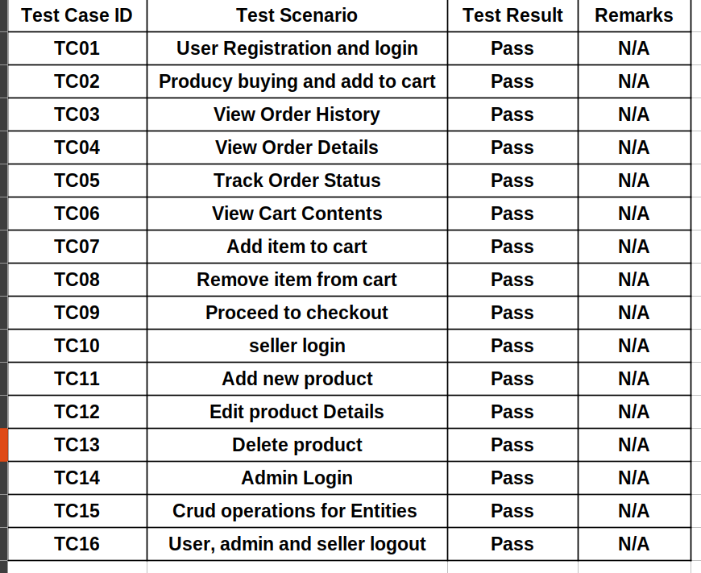

### Limitations of an e-commerce website:

* Data Security:

An e-commerce website deals with sensitive customer information such as personal details and payment credentials. If the website's security measures are inadequate, it can lead to data breaches and compromise customer trust.

* User Experience:

The success of an e-commerce website heavily relies on its user experience. If the website is not intuitive, responsive, or optimized for various devices, users may abandon their shopping carts or find it challenging to navigate, resulting in lost sales opportunities.

* Technical Issues:

Like any digital platform, e-commerce websites are susceptible to technical glitches such as server downtime, slow loading times, or payment processing errors. These issues can frustrate customers and deter them from completing their purchases.

* Competition:

The e-commerce landscape is highly competitive, with numerous players vying for customers' attention and spending. Standing out amidst this competition requires significant investments in marketing, branding, and customer acquisition strategies.

### Conclusion:

In conclusion, e-commerce websites present significant opportunities for businesses to expand their reach and boost sales on a global scale. However, along with these opportunities come challenges such as data security risks, user experience deficiencies, and fierce competition in the market.

Data security is paramount, given the sensitive nature of customer information handled by e-commerce platforms. Breaches or leaks can lead to severe consequences, including loss of trust and legal ramifications. Similarly, ensuring a seamless user experience is crucial for retaining customers and encouraging repeat purchases. Any hurdles in navigation, checkout processes, or mobile responsiveness can drive users away.

Moreover, the e-commerce landscape is saturated with competitors vying for consumer attention and loyalty. Standing out amidst this competition requires innovative approaches and continuous adaptation to evolving market trends and consumer preferences.

However, e-commerce businesses can overcome these challenges by embracing future enhancements and staying ahead of the curve. Personalization, for instance, allows businesses to tailor their offerings to individual customer preferences, enhancing engagement and loyalty. Integration of AR/VR technology enriches the shopping experience, enabling customers to interact with products virtually before making a purchase, thus reducing uncertainties and boosting confidence.

Implementing omni-channel strategies ensures consistency and seamlessness across various touchpoints, whether it's the website, mobile app, social media platforms, or physical stores. This integrated approach enhances convenience and accessibility, catering to the diverse needs and preferences of modern consumers.

Furthermore, adopting sustainability initiatives not only aligns with growing environmental concerns but also resonates with socially conscious consumers. By prioritizing eco-friendly practices in packaging, shipping, and product sourcing, e- commerce businesses can attract and retain environmentally conscious customers, thus gaining a competitive edge in the market.

In essence, by leveraging these future enhancements, e-commerce websites can not only address existing challenges but also unlock new opportunities for growth and differentiation. By delivering exceptional value to customers while maintaining a competitive edge, e-commerce businesses can thrive in an ever-evolving digital landscape